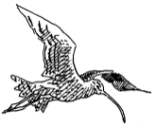
HUDDERSFIELD
BIRDWATCHERS’ CLUB

NEWSLETTER
2021
Registered Charity No. 1098296

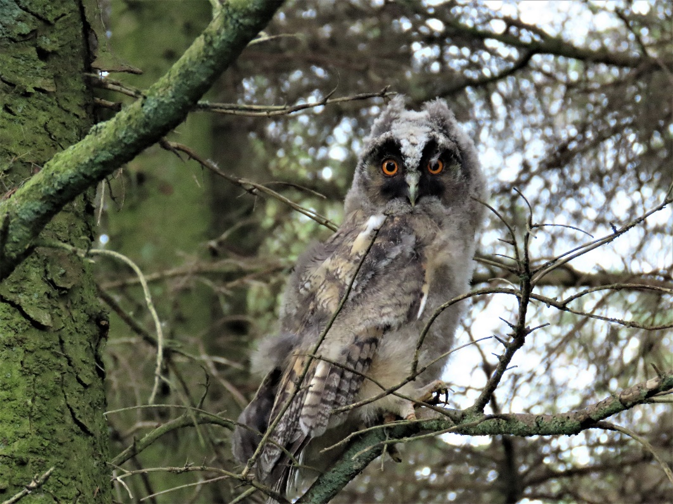

CONTENTS;-
President’s Jottings 2
Questionnaire Feedback 3
Birds of Marsden 4
Birds of Huddersfield 5
Club Meetings 5
A few notes on ‘nocmig’ 7
My local patch – Meltham 8
The first Yearly Report 11
Urban Peregrine’s 17
‘Ups and Downs’ of Patch Watching 18
Go Birdwatching 20
AGM 21
Subscriptions 22
Front cover: Long-eared Owl by Dave Pogson.

PRESIDENT’S JOTTINGS

2020 was progressing very well and we were all looking forward to the returning summer migrants then, in late March, the World changed, as did the lives of everybody. Covid-19 was (and still is) rampaging around the World and the earliest attempts to stem the flow involved ‘Lockdown’. This not only meant that we were limited in our movements, but communications with friends and family were also restricted, as were indoor assemblages. The pandemic had a terrible effect on the lives of everybody: losing loved ones, not seeing family, not getting out for months, etc.
The Club, due to restrictions imposed to overcome the pandemic, had to cancel Patch Outings and also the remaining indoor meetings for the 2019/2020 season. As a consequence, the Committee decided to waive subscriptions for the 2020/21 season.
The Club would not ‘lie down and die’ however and, thanks to investigations by Alf King, Chris Abell and Trevor Doherty, we decided on a programme of Zoom meetings. The first was our AGM in November which attracted some 24 members. As we always discuss recent sightings at indoor meeting, it was thought that a Zoom meeting to cover this topic, and any other bird related topic for that matter, would be an advantage to members – again 24 members attended (not the same 24). The next meeting, organized by Trevor Doherty, was a Christmas Quiz. Some 19 members were educated and entertained by Trevor’s efforts and the meeting was well received by those present. It was becoming obvious that, under the present circumstances, virtual meetings via Zoom were the only way forward.
One of the main objectives of the Club has always been to study and record the wild birds of the area and to publish an annual report. Since the Club’s inception in 1966 this has been achieved, but the situation during 2020 meant that we could not fully meet this objective. However, when all records for 2020 had been computerized, an attempt was made to assess the birds in our recording area, even though breeding season data was limited because of the Covid-19 restrictions in place at the time. Some members, however, found new local patches and supplied valuable records from previously unrecorded areas. I personally found a site within 200 metres of my home which held several warbler species and, more importantly, an unknown House Martin colony. From the records gathered it appears that the only areas which received the usual extensive coverage were Wards End Farm and Blackmoorfoot Reservoir.
I remember well being invited to become a committee member when, in 1967, Mr. Bisiker said “We need some young blood on the committee – Denton will do”. I have now been a committee member, in various guises, to the present day. I feel, however, that my ‘time has run’, and I will be standing down from official duties at the AGM in 2021. One of the main reasons for this decision is the blasé attitude from a few regarding records for the Annual Report. As you are all aware, for a good number of years I, and others, have commented, both verbally and in reports, on the number of under recorded species and records which simply state ‘ubiquitous, so not counted’ – the 2020 report is littered with many similar comments. This is not the only problem as several members are ‘cherry picking’ and only sending in records of the scarcer species. As you can appreciate, this is very frustrating for anyone writing the report and means that justice to the species account cannot be fulfilled as the available records do not allow for a correct assessment of the species’ status to be made.
One of the main aims of the Club, as set out in the Constitution, is “To study and record the wild birds of the area and to publish an annual report”. I feel that, although I have always taken great delight in writing the report, that the present circumstances mean that my enjoyment has been greatly diminished and, as I have said on previous occasions ‘Without records it is
impossible to do justice to the report’. These are long standing problems and something that
cannot be blamed on the Covid-19 pandemic. As a consequence, I feel that I can no longer do justice to the annual report and the 2020 report will, therefore, be my last.
2

I would like to thank everybody who has assisted with the running of the Club, along with all members who have played their part in the Club’s success. This has been an extremely difficult year
for the Club but, with your continued support, the Club can prosper – albeit in a totally different environment.

Mike Denton

Questionnaire Feedback

First of all I would like to thank the 33 people who responded to the questionnaire I sent out in June. The purpose of this was to inform the Committee about the way forward for the coming season.
A total of 77 members were reached by email, letter and the Forum. Of the 33 replies received only 2 indicated that they would not be paying their subscriptions. 26 said they would be attending Indoor meetings when circumstances permit and 21 have indicated they would join Zoom meetings if there was no alternative.
At the time of writing (early July) we are waiting for Kirklees policy decisions on opening up meeting rooms and it is unlikely that this will be known in sufficient time for us to plan a set of Indoor meetings starting in September. However we will be organising some Zoom sessions for the rest of 2021 which could be switched to actual meetings if allowed.
It was interesting to note that a number of respondents indicated that we need more new, younger members. I wholeheartedly agree with this and have taken a number of initiatives with local groups and the University but with little success. More ideas on the how to do this would be welcomed and it would help if all of us recruited a new member. Younger people tend not to join societies and use social media for interactions.
Unfortunately there were no definite volunteers for Committee, Website or Recorder but it was very pleasing to note 7 people offered possible assistance in varying forms. They will be contacted on a 1 to 1 basis at the appropriate time.
Some members who never attend Indoor meetings said how much the Annual Report was enjoyed. This cannot be produced without records, a Recorder, writers and Editor. It is essential to the future of the club that someone is prepared be the Recorder. It is likely that we have to find a more efficient way of capturing records. if not, a slimmed down Report is inevitable.
As we are all too well aware the Covid pandemic has affected us all in many ways affecting our physical and mental health, restricting our freedoms, particularly being unable to meet our loved ones. The Club has not been immune to these effects. Much as we may like it to be, things will never go back to exactly as they were before Covid.
Five members of the Committee have indicated that they will not stand for re-election again and members must be aware of this to avoid the club withering away. Your help is needed. You need not be an expert birdwatcher; you will have many life skills which together with enthusiasm and a small-time commitment are all that is needed.

Chris Abel

3

THE BIRDS OF MARSDEN
By Mike Pinder

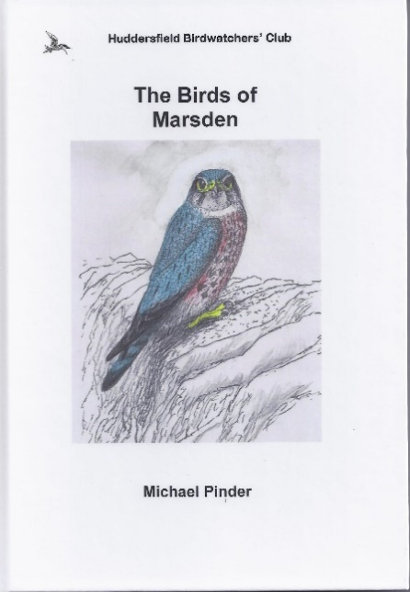
Huddersfield Birdwatchers’ Club is proud to publish a new book by Marsden resident and longstanding Club member Mike Pinder. Mike’s thoroughly researched book takes us through the ins and outs of birding in Marsden and the 173 species that have been recorded. Migration is a particular interest of Mike’s, and his experiences are reflected in his accounts of all the migratory birds.
There are colour photos, all taken in Marsden and Mike’s own delightful colour illustrations, including the cover.
The book is a quality production as a section-sewn hardback. 98 pages.

Order now from Mike Denton: 77 Hawthorne Terrace, Crosland Moor, HD4 5RP
michael@atheta.plus.com Tel. (01484) 646990

Price £10 plus £2.50 p&p (or collect).
Cheques should be made payable to Huddersfield Birdwatchers’ Club.

4

Birds in Huddersfield

Our annual report for 2020 is currently being written entirely by Mike Denton and David Sill, based upon the records analysis by Recorder Nick Mallinson. Stuart Brocklehurst has produced another great piece of art for the cover – this time a stunning Magpie
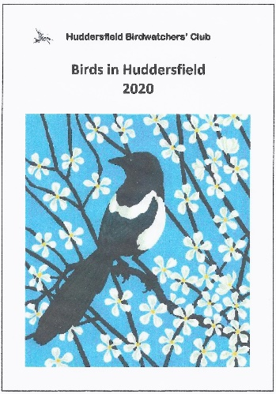
.

Details of how to get your copy will be announced when the report is printed

CLUB MEETINGS 2021/22
By Alf King

In the last Club season, it was not possible to organise or run any indoor meetings due to the pandemic emergency. We were all hopeful that this would subside quickly and that we could return, once more, to these ever-popular meetings, listening to excellent presentations about all things birding and meeting up with friends old and new. Unfortunately, the continuing situation makes this highly unlikely, at least in 2021, so we have made plans accordingly.
During the last season we organised some on-line presentations using Zoom as a substitute and these were well received by those who tuned in to listen and learn, generating audiences of around 25

5

people on average. Of course, using this sort of technology isn’t for everyone either due to a lack of
resource, technical knowledge or preference and this is perfectly understandable. We have racked our brains for any other approach that might be more favourable for all members but, just like other organisations of our size, have found that Zoom type presentations are the optimum under these circumstances. As a bonus it may also offer us the opportunity to get speakers from further afield than before.
The survey of members that Chris Abell carried out showed that there continues to be an acceptance, as distinct from over-riding enthusiasm, for Zoom meetings for as long as we are unable to offer an alternative. In addition, from the survey, it is obvious that many of us look forward to being able to meet up again but still feel that the risks outweigh the benefits at the moment. In the light of this we have decided to organise an initial half-season’s programme, up until the end of 2021, featuring further on-line presentations. If things suddenly improve then we would be able to reorganise these at short notice to be replaced by live meetings. Whilst the situation continues to be fluid our expectation is that live meetings will continue to be unlikely before the year end. We have, therefore, put together a schedule of virtual meetings for the immediate future and hope that as many people as possible will be able to join us at these.
The schedule that we have organised so far is as follows:

Sept 7th The Best of Britain: From Ardnamurchan to The Forest of Dean
by Tom Mabbett (Naturetrek)

Sept 21st Bird Chat

Oct 5th Birding in Morocco
by Richard Bashford (Naturetrek)

Oct 19th Bird Chat

Nov 2nd AGM & Bird Chat

Nov 16th The Miracle of Bird Migration
by Mark Pearson

Nov 30th A Journey Around British Bird Reserves
by Gary Prescott (The Biking Birder)

Dec 14th Christmas Quiz 2021

Jan 18th Willow Tits and Other Species on The
brink
by Laurence Rose

A FEW NOTES ON ‘NOCMIG’
By David Pennington

For several reasons, nocturnal sound recording (or nocmig, as it’s commonly known in Britain), has seen a sharp increase in popularity among birders during the past couple of years. A lot of useful information is now available on various websites, but what follows is a brief outline of my own current method and some recent results.
Typically, I use an Olympus LS-3 recorder with furry windshield, facing into a parabolic dish. This
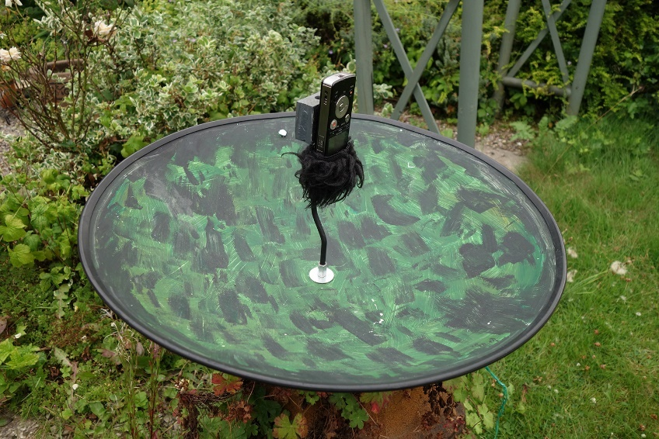
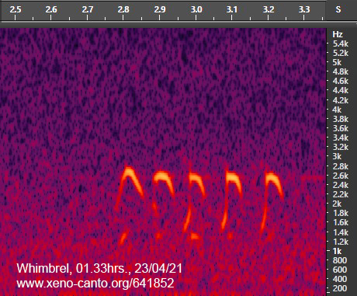
particular recorder is now discontinued, but there are similar models available new from Olympus and other companies such as Tascam. One of the benefits of the LS-3 is that it is programmable (i.e., you can set the start and end times of the recording), but since most of my nocturnal recording is done in the garden this isn’t strictly necessary. The recorder is usually wrapped in cling film, but because it is facing downwards can also be encased in the bottom half of a small plastic bottle for even better protection. The parabolic dish was bought on its own (i.e., without microphone) from a company in Cheshire for £50, which is a fraction of the cost of some well-known alternatives. Again, a dish is far from essential, and in some cases
Equipment shown is as above

7

might even result in some sounds being missed altogether, but I’ve found that the positives outweigh the negatives.
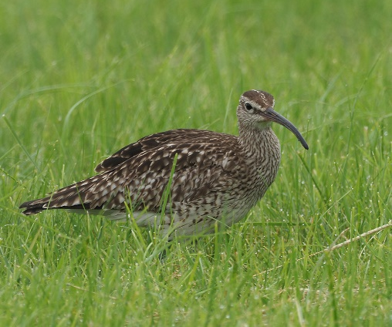
My usual recording mode is .WAV 44.1kHz mono (stereo is pointless with a dish), at maximum gain, which produces file sizes of around 335Mb per hour. The file is then opened in a software program (I use Adobe Audition, but a good alternative is Audacity, which is freely available online), where the resulting sonogram (or, more accurately, spectrogram) is analysed visually in half-hour chunks. It’s a lot easier than it might sound, honest! It’s also quite quick, taking about one-tenth of real time once you’ve learned to recognise potentially interesting shapes among those of dogs, cats, drunken people, car horns, gate latches, wind chimes, etc.
Whimbrel by Dave Pennington
Although nocmigging is not a new thing, in some ways it’s still in its infancy, with much still to be discovered. It seems, for instance, that the artificial lights of built-up areas can be an attraction for migrating birds, perhaps sometimes acting as ‘leading lines’, and some such places are now producing results comparable to those from known migration hotspots. Among several specific examples, it has drawn attention to the easterly movement of thousands of Common Scoters over Northern England in spring, and a pronounced peak of Water Rail passage in the last week of March. Alongside these two species, my own personal highlights so far this year have included an Avocet on 22nd April, Whooper Swans on four nights, Whimbrels on two, as well as Little Grebes, Wigeon, Teal, Redshank, Common Sandpipers, regularly appearing local Barn Owls, and a couple of tantalising mysteries which might yet still be identifiable.
Photos by David Pennington

MY LOCAL PATCH – MELTHAM
BY DAVE POGSON

I have lived and birded the Meltham area for 40 years. Over this period, I have seen many changes in numbers and species of birds and it's not all bad news, far from it.
I am fortunate to live on the edge of the moors and though this is probably my favourite habitat it is by no means the only area I visit on a regular basis.

8
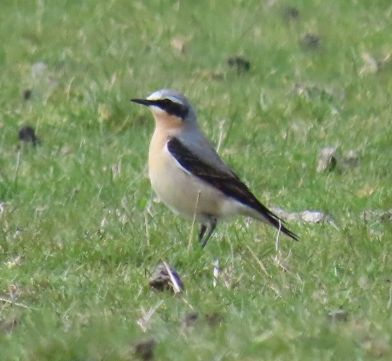
Even the bleakest Winter months can be rewarding if you’re prepared to put the time in, but it is the coming of Spring I most look forward to each year.
Hearing and seeing the first returning Curlews always gives me a buzz, a few fields off Deer Hill End Road can attract good numbers with gatherings of 70+ birds by mid-March in the past, though numbers have been somewhat lower in recent years, 55 together was my largest count this Spring. A few pairs stay to breed whilst others, no doubt continue North.
These are sometimes joined by one or two Oystercatchers, a relatively recent breeding species to the area.
Wheatear by D. Pogson
Lapwings are just about holding on and usually succeed in rearing a few young in some of the rougher fields despite the attention of the growing Crow population.
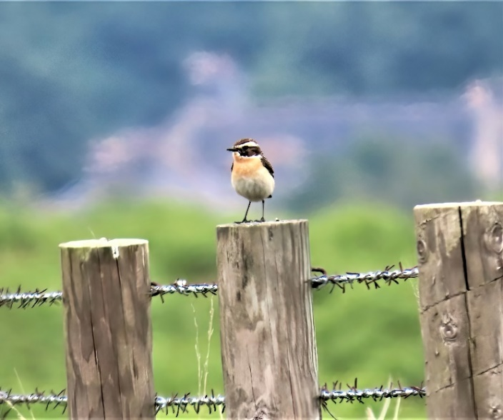
Ring Ouzel, always great to see and didn't disappoint this year with three birds in fields near Royd Edge Clough from 7th April staying to the month end. Another confiding male of this usually skittish species graced a field off Red Lane in late April and was joined by some very immaculate looking Wheatears plus up to five Whinchats that also found this same field to their liking. It was heartening that two pairs of the latter bred in the Brow grains area this year.
Unfortunately for the second year running no Twite were recorded at the Deer Hill feeding site. Better news came in the form of up to four ‘reeling’ Grasshopper Warblers by the end of April, this is
Whinchat by D. Pogson
another recent, and most welcome coloniser.

9
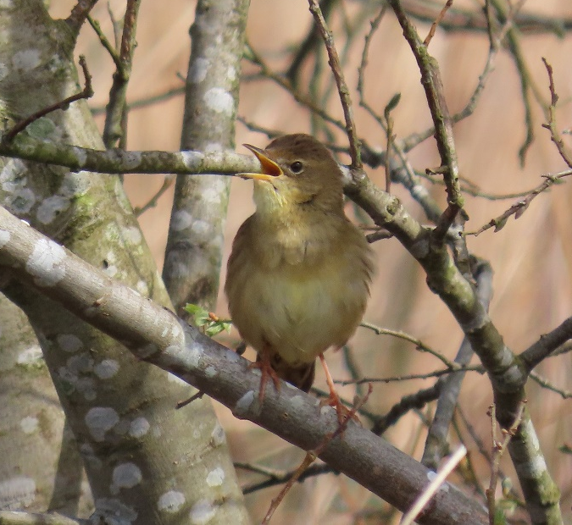
Stonechats seem to be having another decent breeding season this year.
A smart looking male Redstart was a nice surprise in a small wood near Brow Grains, a first here for a good few years, this bird sang till the end of May but there was no evidence of breeding.
Cuckoo is another bird I look forward to hearing every Spring. Up to four calling males this Spring was about normal, two in the Brow Grains area, one in the wood near Deer Hill Res. and one in Royd Edge Clough, all as unapproachable and hidden in the trees as usual, with flight views and the occasional bird perched on overhead wires giving the best views. No sooner have these birds turned up before they seem to be on their way back with none heard after mid-June.
Grasshopper warbler by D. Pogson
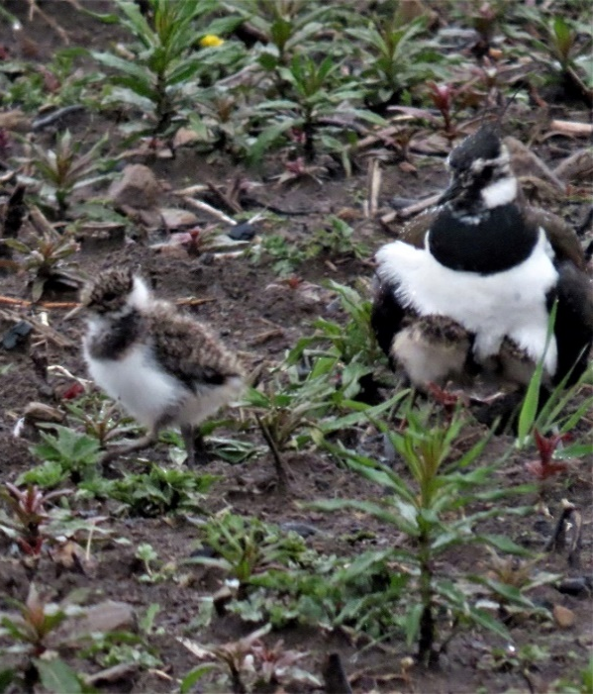
Another site I regularly visit is Meltham SF. This site held up to four wintering Chiffchaffs here in 2020. Searching through the many Pied Wags in April can often turn up an immaculate White Wag with up to a dozen Greys here during the colder months and the chance of Yellows in Spring.
It was here that produced one of the most mesmerising sights this Spring. Along with my brother Steve one day in the unseasonable weather of mid-May we estimated at least 200 hirundines over the filter beds and beyond, probably 95% were House Martins.
Come mid-May I'm inclined at times to wander off piste somewhat.
LAPWING WITH YOUNG BY D. POGSON
The Wessenden Valley has turned up some decent birds over the years.
Wessenden Head Res regularly produces Little Ringed Plover, Dunlin and breeding Common Sandpiper. But it is the promise of Bops that draw me here.
Over the years I've seen Osprey, Red Kite, Marsh and Hen Harrier Sparrowhawk, Goshawk, Common Buzzard and the commoner four Falcons plus Short-eared Owl and Raven. A three hour yomp on the top catchment path brings me back to Deer Hill Res with the hope that the water level drops as summer progresses bringing a decent wader to this site. The best I've had here in the past are Purple Sandpiper and Sanderling. I always live-in hope but at least this May a couple of nice Whimbrel put on a decent show and were most welcome.

10
Nearer home the thorn hedges on the catchment between Red Lane and Hassocks Road are well worth checking from late Summer to early Autumn, with Common Redstart, Common Whitethroat and Spotted Flycatcher just about certain here during August. Other birds here at this time of year have included Tree Pipit, Lesser Whitethroat and Sedge Warbler plus the usual Willow Warblers and Chiffchaff though I'm still waiting for my first Wryneck and Yellow-browed Warbler.
In late Summer over recent years there has been a build-up of Goldfinches that feed on the abundant thistle heads by Deer Hill Res. The flock of c150 birds in 2019 included a leucistic bird that looked strikingly white from a distance. There's usually a couple of Sparrowhawks in attendance and I've seen Merlins on several occasions hunting them too. As Summer gives way to Autumn there can often be a noticeable build-up of Stonechats, anywhere from Brow Grains to Deer Hill Res, and the Res run off channel can be worth checking from September onwards. I've seen a few Rock Pipits here over the years, usually singles, but sometimes two that usually hang around for a few days. I was lucky enough to find a Water Pipit here in November 2016, this bird was seen on several dates to the year end. What was probably the same one was seen at the same site but now in summer plumage at the end of March 2017. Again, what was probably the same bird wintered here from November 2017.
The Winter period can seem pretty barren in the Deer Hill area and along with my brother Steve and a few other hardy souls try to make the effort to concentrate on the Gull roost at Blackmoorfoot Res on suitable late afternoons, but that's another story.
The local patch is not ignored at this time of year and can be a good time to see the odd one or two nomadic ring-tail Hen Harriers and sometimes in a good vole year Short-eared Owls can be seen quartering low over the rough ground.

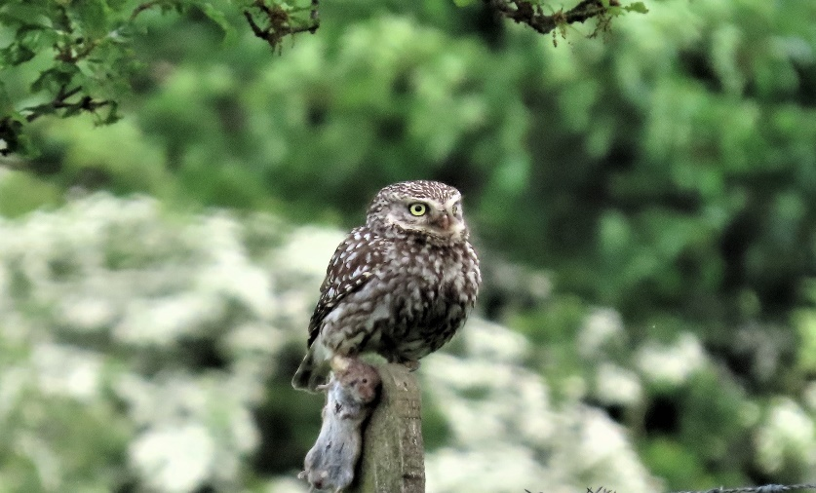
December10th 2020 will live long in my memory. As I got near the top of the track at Brow Grains there on the overhead wires was a stunning Great Grey Shrike. It flew onto a nearby fence post and showed well briefly, before being spooked by a toy balloon and flying off low never to be seen again. By the time Steve and the others arrived the bird was long gone. I did manage a very poor record shot with a small camera, and it was this that made up my mind to buy a half decent camera and always have it with me.
Little owl with vole. D. Pogson
Anyway, it was a great way to end the year.
The last word though, should go to the five species of breeding Owls within walking distance of home. Two pairs of Long-eared, four pairs of Short-eared, two pairs of Little Owl, one pair of Barn Owl. Also, thanks to my good mate Tim Duckworth for showing me the two Tawny Owl nests he found in tree splits.
I'd like to point out that these can be watched from a sensible distance with binoculars without causing disturbance.

Dave Pogson.

11
THE FIRST ANNUAL REPORT 1966
BY C. DISBREY. RECORDER.

This, the first Annual report of the Club, records 135 species for the area. Although this is two fewer species than last year it is based on a greater number of reports, and the thanks of a satiated recorder are extended to all the members – and an occasional non-member – who have contributed such a large volume of records.
But the lesser Whitethroat is a very interesting item. The most notable species missing from the 1967 list are: Black Tern, Little Gull and short-eared Owl, but the lesser whitethroat is a very interesting item. The recording of Slavonian Grebe and Black-necked Grebe completes the five species of Grebe on the British list during the first two years of the Club.
It is unusual to have all three species of swan – Mute, Bewick’s and Whooper in the year. The 23 Bartailed Godwits on Nov. 11th is a very good record- very interestingly confirmed by the sighting of the same birds three quarters of an hour earlier flying W. at Fairburn Ings.
This year reports of Great Spotted Woodpecker are far more numerous then reports of Green Woodpecker which, except for one location, are very few.
#It is unfortunate that the PIED Wagtail roost has broken up, but it will be interesting to see if it re-forms on next year’s growth of reed. The absence of reports of Yellow Wagtail from Cooper Bridge probably indicates that the area was not visited

THE GREAT CRESTED GREBE. four pairs at Bretton. Three nests noted but only one juvenile seen. A pair were displaying at Ingbirchworth res. on March 29th. On August 28^{th,} a bird was seen to leave a nest which had eggs, and on Aug. 29th two adults were seen with two very small chicks. On Oct. 5^{th,} the juvs. Were well grown. Reports of occasional birds at Blackmoorfoot res. Aug 27th and 28th.
SLAVONIAN GREBE. a single bird, in mainly summer plumage, was on Ingbirchworth res. On Aug. 27th and 28th.
BLACK-NECKED GREBE. Several members of the club had good views of a single bird in full summer plumage on Black Moorfoot res. On April 26th.
LITTLE GREBE. Regularly at Bretton, frequently at Ingbirchworth res. With 6 on Oct. 5th. Occasionally at Black Moorfoot res. With a report of 11 on Nov. 9th.
CORMORANT. Two on Black Moorfoot res. on Oct. 1st
HERON. Regularly reported from Bretton with a maximum of 4 on July 7th. Reports from Ingbirchworth, March Haigh, Digley and Black Moorfoot reservoirs.
MALLARD. A maximum of 187 at Bretton on Oct. 8th. 65 at Black Moorfoot res on Dec. 127th. Small numbers frequently at Ingbirchworth res. and reports in May and June from Swellands res.
TEAL. Reported from Bretton until April 23rd and from July 7th with a maximum of 27 on Nov. 11th. Occasionally at Black Moorfoot res with C.30 on Nov. 9th and at Deerhill and Wessenden reservoirs. Gamekeepers report more Teal than usual on the moors in the Dunford Bridge area.
GADWALL two males and one female on Sept. 30th on Black Moorfoot res. One at Bretton on Sept. 24th.
WIGEON C.20 on Black Moorfoot res. Nov. 9th and reports from Bretton and Brownhill, Digley and Ingbirchworth reservoirs.
PINTAIL 6 on Black Moorfoot res. Nov. 9th with single bird reports from Black Moorfoot res. on April 5th and Ringstone res. on Jan 2nd. A male and female at Bretton on Dec. 3rd.
SHOVELER one on Ingbirchworth res. on July 25th and 3 on Black Moorfoot res. on Nov.9th.
TUFTED DUCK reports from Bretton regularly and from Black Moorfoot, Ringstone, Bilberry, Swellands and Black Moss reservoirs.
POCHARD regularly at Bretton with 25 on January 1st. Occasionally at Black Moorfoot and Ingbirchworth reservoirs.

12
GOLDEN EYE last spring report April 14th at Deerhill and the first autumn report Oct. 29th at Ringstone Edge res. Regularly at Black Moorfoot and Deerhill, with records from March Haigh and Ingbirchworth reservoirs and from Bretton.
COMMON SCOTER a male at Black Moorfoot reservoir on Aug. 10th.
GOOSANDER a female at Bretton for a period at the beginning of Jan.
SHELDUCK two on Jan. 30th, four on March 17th, one on Aug. 31st at Black Moorfoot res. One on March Haigh res. April 9th and three on Ingbirchworth reservoir on Oct. 28th
GREY GEESE several reports of skeins passing over the district.
PINKFOOTED-GOOSE 27 flying W. on Oct. 5th following the contour of the hills above Digley res. were close enough for identification.
CANADA GOOSE regularly at Bretton with 133 on July 9th 28 Juveniles were raised from 6 broods.
MUTE SWAN again bred successfully at Middlemost Mill Dam, Halifax Old Road, Huddersfield.
WHOOPER SWAN 6 juveniles and 2 adults on Ingbirchworth res. on Nov. 17th. This is the only record for the area in the last nine years. Although the species is a regular winter visitor to S. Yorkshire.
BEWICK’S SWAN Jan. 8th Black Moorfoot res. 20 adults and 7 juveniles on a small area of unfrozen water. One juv. At Ingbirchworth res. on Jan. 22nd and 3 adults on Ingbirchworth res on Dec. 13th.
SPAROW HAWK two only reliable sight records of this dwindling species, in the early part of the year, from a traditional breeding area.
GOSHAWK a very large hawk, which was seen to perch for a very short time at close range, in woodland, giving a good view of the buff breast with dark striations was probably an immature Goshawk. The escape of a Goshawk was reported in the local press about the same time.
MERLIN one on June 1st near Meltham and two on June 17th at Ravenstones.
Kestrel Regularly reported throughout the area and over the town.
RED GROUSE reported from Deerhill, Cupwith, Bilberry, Digley and Yateholme areas.
PARTRIDGE reports from 9 localities would appear to indicate an improvement of the status of the species in the area.
PHEASANT mainly confined to a few woods where it is preserved.
WATER RAIL regularly seen and probably breeding in the vicinity of Bretton.
WATER HEN common in suitable habitat
COOT up to 17 at Bretton in the early part of the year and present throughout the year. Also, regular oat Gunthwaite and occasional birds at Black Moorfoot res.
OYSTER CATCHER two on Aug. 1st and 2 on Aug. 19th at Black Moorfoot res.
LAPWING well distributed with large winter flocks in the Ingbirchworth res area with a flock of 1,200 on Aug. 21st.
RINGED PLOVER one at Deerhill res. and two at Ringstone Edge res on May 5th, with 7 records in the last two days of July and in early Aug. during the autumn migration.
GOLDEN PLOVER breeding on the moors in the western and southern parts of the area, with winter flocks on lower ground, particularly in the South Crosland and Ingbirchworth areas. On April 212th near Wills-o-Nats mating was observed between what appeared to be a northern race cock and a southern race hen.
TURNSTONE one at Deerhill res. and here at Black Moorfoot res. on May 6th.
SNIPE regularly at Black Moorfoot res and Outlane/Wholestone moor. Also, at Ingbirchworth and Ringstone res., near Emley, South Crosland and Deerhill.
WOODCOCK a bird with three young at Bretton on June 4th, and reports of single birds at Harrow Clough, Dean Wood and Grimescar. Roding at Holmbridge and Boothroyd Wood during the latter half of June.
CURLEW regular on the moors. First heard calling March 4th at Ingbirchworth and the last sighting report was on Aug. 9th at Deerhill.
WHIMBREL two over March Haigh res., BUCKSTONES ON May 21st, and one at Black Moorfoot
13
res. on July 31st.
BAR-TAILED GODWIT 23 flying W over Blackmoorfoot res. at 12.35 hours on Nov. 11th is a very unusual record for this area.
GREEN SANDPIPER a single bird at Bretton on Aug. 20th
COMMON SANDPIPER reported from the larger reservoirs in the district. First report April 11th at Brownhill res. Last report Aug. 25th at Black Moorfoot res.
REDSHANK reports of occasional birds from the moorland res.
GREENSHANK two at Black Moorfoot res. on July 30th, and one at Ingbirchworth res. on Aug. 28th.
DUNLIN reports from the vicinities of moorland reservoirs, with one nest of four eggs being incubated on May 21st. near Swellands res. and 3 chicks reported from Deerhill on June 3rd.
SANDERLING one in summer plumage at Black Moorfoot res. Aug. 8th.
GREAT BLACK BACKED GULL small numbers regularly at Black Moorfoot, Ingbirchworth and Ringstone Edge reservoirs during the winter months, with 10 at Deerhill res. on May 5th.
LESSER BLACK- BACKED GULL Black Moorfoot, Ingbirchworth reservoirs and Bretton Park.
HERRING GULL throughout the early part of the year at Black Moorfoot, with small numbers at Bretton Park.
COMMON GULL Regularly at Black Moorfoot res. during the winter months.
Also, at Bretton.
Nov. 26th at Ringstone Edge. “Light grey mantle – no black on primaries – grey markings on head – heavy bill. Flew off with two Great Black-backed Gulls – similar size and same steady wing beat.”
BLACK -HEADED GULL very numerous and common. On Sept. 21st at Berry Brow, birds of this specie were observed settling on the tops of Hawthorn trees and Elderberry bushes and eating the fruit.
COMMON TERN/ARTIC TERN reports of single birds at Bretton on July 7th, July 10th and Sept 10th.
STOCK DOVE regularly seen in the vicinity of Digley res. Reports from Bretton, Deerhill, Dean Wood, Birds Edge and Ingbirchworth.
WOOD PIGEON c.600 moving S. at 09.00 hrs. from Whitley Pak on Jan. 29th and 300 at Ingbirchworth on April 28th.
TURTLE DOVE June 10th Ingbirchworth res. area. June 15th Yateholme, July 17th, 23rd and 25th at Bretton Park
COLLARED DOVE one at Bretton on April 30th. In the Edgerton area of Huddersfield 3 were reported on April 2nd, 2 on April 9th, one on April 23rd and 2 in early December.
CUCKOO reports from more localities than last year, with a juvenile of red-brown form reported from Netherton and a rufous female in the Digley area. The first Cuckoo was reported to have arrived in the Digley area on April 27th.
BARN OWL one bird was reported Aug. 15th and 2 birds were seen by several members on Aug.17th. A local resident said they had been in a nearby barn for several weeks. One was still in the area on Oct. 23rd.
LITTLE OWL reports from Digley, Holmbridge, Black Moorfoot, South Crosland, Grimescar and Castle Hill.
TAWNY OWL reports from eight districts.
SWIFT first record May 2nd from Crosland Moor and the latest record from Lindley Moor on Dug. 31st.
KINGFISHER reports from Bretton in April and June, with regular reports from Bretton in November and December. Also, a report via a fisherman of a sighting at Hilltop res. above Slaithwaite.
GREEN WOODPECKER regular records from Dean Wood. The only other reports during the year are: 1 bird at Meltham Mills Woods on April 14th, and 4 at Bretton Park on April 22nd.
GREAT SPOTTED WOODPECKER reports from 14 localities were much more numerous than last year.
14
LESSER SPOTTED WOODPECKER three reports from the Bretton area. Three moving through Bretton Park on April 16th
SKYLARK well distributed with a flock of C.50 in the Ingbirchworth area at the beginning of March, and 50+ at South Crosland on Oct. 22nd.
SWALLOW the first record of the year was at Bretton Park on March 27th, and the last on Oct. 19th, covering a much longer period than last year.
HOUSE MARTIN April 22nd saw 4 at Bretton Park. The last sighting of the year was on Oct. 20th at Digley.
SAND MARTIN reports of between 20 and 40 at Bretton Park on April 22nd, the latest report being two at Bretton Park on Sept. 3rd.
CARRION CROW well distributed.
ROOK probably 30+ rookeries in the area, with a large one of appro. 150 nests at Shelley. A large flock frequented the High Flatts area at the beginning of the year with c.2,000 on Jan 22nd.
JACKDAW widely distributed.
MAGPIE very common and numerous with a roost of C.130 in woodland between Old Lindley and Jagger Green on Feb. 5th.
JAY well distributed in the woodlands.
GREAT TIT common.
BLUE TIT very common.
COAL TIT thinly distributed through the woodlands. Several reports of regular visits to bird tables.
MARSH TIT two reports only. A party of 6 at Bretton Park on March 27th and one at Emley Woodhouse on Sept. 24th.
WILLOW TIT reports from 6 localities.
LONG-TAILED TIT a good number of records of mainly small parties and single bids, but regular reports from Bretton Park with at least one pair breeding there.
NUTHATCH four records from Bretton Park of single birds.
TREECREEPER breeding at Woodsome Lees and regularly seen during the breeding season at Bretton Park and Grimescar.
WREN common.
DIPPER recorded in 6 localities. One caught and ringed in Dean Wood was the first of this species to be ringed in the Huddersfield area.
MISTLE THRUSH well distributed, with successful breeding within a few yards of the busy Bradford Road in a built-up area of Huddersfield. A large flock in the Grimescar area during Sept. and Oct. reached 130+ on Oct. 4th.
FIELDFARE this species was very numerous in the district in the early part of the year, with a flock of 400+ roosting in Digley Wood on April 6th, 300 at Stocksmoor, Thurstonland on April 1st. 300 at Wilshaw on Feb.26th with a small party at Knowles top, Meltham as late as May 3rd. The first arrivals in autumn were three seen flying N. on Sept. 21st at Lindley Moor.
SONG THRUSH Well distributed.
REDWING C.5 in a flock with 20 Fieldfares were recorded at Bretton Park on April 16th, and the first autumn arrival was on Sept. 25th when C.25 were seen in the Beldon Valley. This species appears to be more numerous in the area than last year. A flock of C.230 in Grimescar Valley on Nov. 4th and a roost of C.600 in Edgerton on Nov 18th.
RING OUZEL many more reports than were received in 1966, and from 5 areas. Four pairs reported from the Buckstones area – two with juvs. Juvs also reported from the Holme area.
BLACKBIRD very common
WHEATEAR C.30 at Deerhill on July 9th. First record March 27th near to Emley village – last Report Oct. 4th, Grimescar.
STONECHAT two juvs near Ingbirchworth res. on Nov. 21st.
WHINCHAT The first record April 23rd at High Flatts the last report Sept. 13th at Grimescar. Probable breeding at Royd Edge Meltham.
REDSTART First record April 23rd at Bretton Park, and the last record Sept. 18th from Dean Wood.
15
ROBIN very common. A report of singing at midnight in the centre of Holmfirth on April 15th.
GRASSHOPPER WARBLER one singing at Woodsome on April 28th and heard regularly at Bretton Park from April 22nd until July 9th.
SEDGE WARBLER single birds at Bretton Park on May 7th and Black Moss on May 17th.
BLACKCAP more records than for 1966, with reports, including migration movements, from 13 localities. Heard at Bretton as early as April 2nd. Breeding near Lockwood Cemetery with the female still in the area on Oct. 15th.
GARDEN WARBLER two in song at Bretton Park on May 7th. A report of 2 in Dean Wood on June 11th. The latest record for the year from Bretton Park on July7th.
WHITETHROAT many more reports than in 1966. The first record on April 30th from Bretton Park, with the last record from Toothill on Sept. 25th.
LESSER WHITETHROAT male and female seen at the edge of Bridge Royd Wood, Bretton Park on July 23rd, and one near Holywell Green on Sept. 3rd.
WILLOW WARBLER common. First record April 16th at Holmbridge; the last record Sept. 29th at Grimescar.
CHIFFCHAFF first record April 2nd at Bretton Park and the last report from Longley on Oct. 3rd.
WOOD WARBLER song heard in Mollicar Wood on April 29th and in Grimescar Wood from April 29th until June 2nd. Also singing in Dean Wood from May 21st until June 6th.
GOLD CREST reported regularly from Yateholme, Dean Wood, Grimescar and Bretton Park.
SPOTTED FLYCATCHER the first report on May 9th from Bretton Park, and the last record from Thunderbridge on Sept. 25th.
DUNNOCK very common
MEADOW PIPIT C. 80 roosting in the heather on Lindley Moor on March 31st. A flock of C.100 was presr4nt in the Digley/Bilberry area on July 21st.
TREE PIPIT Records from 13 localities. The first report of the year from Bretton Park on April 23rd, and the last report, also from Bretton Park, about Aug. 15th.
PIED WAGTAIL 100+ arrived at the Waterloo roost between 18.00 and 19.00 hrs. on Oct. 1st. but the roost had broken up on Nov.18th probably because the reeds had been battered by bad weather.
WHITE WAGTAIL single birds at Kirkburton Sewage Farm on March 25th, and at Bretton Park at the River Dearne on April 30th, were considered by the observers to be of this sub-species.
GREY WAGTAIL well reported from 12 localities.
YELLOW WAGTAIL regular reports from Bretton Park. 7 at Blackmoorfoot res. on Aug. 22nd. Single birds at Longwood Edge and Dean Wood, and 3 Elland Gravel Pits on May 29th.
WAXWING one reported 27th in the New Hey Road area by the Huddersfield Examiner.
STARLING very common. A very large flock estimated at C.250,000 flew E. in the evening of Nov. 11th at Bretton, and what was probably the same flock was seen to fly W. in the morning of Nov. 15th at Bretton Park.
GREENFINCH very common, with a flock of 300+ at South Crosland on Feb. 5th.
GOLDFINCH many more reports received than in 1966, mainly outside the breeding period. A ‘charm’ of 21 was reported in the Grimescar area on Sept. 29th, Oct. 6th and Oct. 13th.
SISKIN a single bird at Stainland (Black Brook) on Feb,. 5th. 7 on Feb. 12th, 2 on March 12th, one on March 27th at Bretton Park. 6+ at Meltham tip on March 14th, and a single female on April 9th at Ingbirchworth.
LINNET well distributed and occurring in mixed flocks with Greenfinch. A flock of C.200 was in the Holmbridge area during Sept. and Oct.
TWITE well reported from the habitat on Deerhill with 20+ on May 21st. At Royd Edge Clough, Meltham on Sept 22nd and a mixed flock of 150+ was comprised of approx.. 75% linnet and 25% Twite.
REDPOLL numerous reports from a total of 10 localities, with regular reports from Grimescar and Bretton Park during the breeding season.
BULLFINCH many reports from 14 localities.

16
CHAFFINCH Well distributed but not numerous, a flock of 60+ at Whitehead Lane, South Crosland on Jan. 29th and C.60 roosting in Edgerton on March 5th.
BRAMBLING many records in the early part of the year with a roost of C .500 in Edgerton. A cock and a hen reported at Farnley Tyas as late as April 29th. The first autumn arrival was recorded at Digley Wood, Holmbridge – a single bird with Chaffinches and Redpolls on Oct. 20th but very few migrants were in the area during the last months of the year – the maximum report being 5+ at Grimescar on Nov. 19th.
YELLOW HAMMER usually reported in small parties near woodland.
CORN BUNTING reports from 8 localities.
REED BUNTING well reported from 10 localities.
SNOW BUNTING a single record of 10 on Nov. 26th near March Haigh res., near Buckstones.
HOUSE SPARROW very common.
TREE SPARROW well distributed and occurring regularly outside the breeding season in mixed finch flocks.

Thought this might interest you. Ed.

Urban Peregrines.
By Dave Sill

It has been well publicised nationally for some time that this species is flourishing in Towns and Cities throughout the country and the breeding pair on Wakefield Cathedral have been followed on camera by thousands as well as by our members, who were treated to an excellent talk at one of our indoor meetings. Well, in 2019, our second pair of ‘ Townies’ took up residence much to the delight of local residents and though, as with the first pair, these were not in the town centre as such, unlike many pairs, the site was adjacent to an estate and plenty of houses and offered good views to the locals who took a great interest.
The nest site was in a very safe, high, inaccessible place and there were great hopes. However, one morning we were alerted to the fact that a long builder’s ladder had been attached to the bottom of the building and it was obvious that work above was intended. The Police were called, the Wildlife Officer attended and notified the owners that they must proceed no further or cause any further disturbance and that whilst disturbing a site is not against the law out of the breeding season, it most certainly is during it. All went well and 3 young successfully fledged.
By last year, unlike the previous one, a planning application to carry out the work on the top of the building had been submitted. Work which would have made any further breeding on the site very difficult if not impossible. Objections to the application were quickly organised and as well as a petition from a good number of local people many individual objections were sent in, many of which, we are pleased to say came from our members. This was successful and the owner had to submit a revised application which did ‘water down’ the original plans somewhat but still didn’t go far enough as far as the Council was concerned and it was rejected. The birds bred again and fledged another 3 young.
Again, as we speak in July 2021, 2 young have been reared making a total of 8 so far with hopefully many more to come in future years. (Watch this space).

17

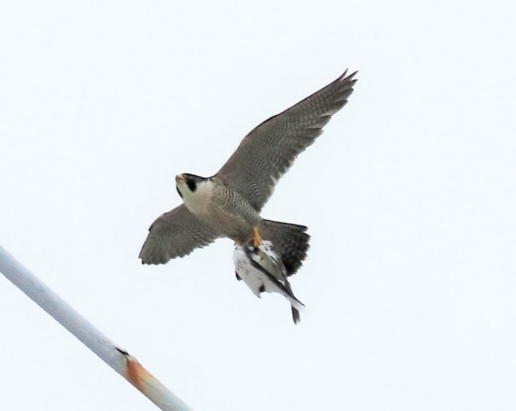
It goes to show that whilst Peregrines are doing very well away from their more traditional, much riskier and dangerous breeding places, there are always potential risks, many quite innocent with unintended disturbance, along with wires, windows, aerials and the rest of human clutter. The big plus apart from a safer nest site is a readily available supply of food. The above pair have obviously been watched carefully whilst feeding the young and all the identifiable prey brought by the female was feral Pigeon whilst for the male it was Starling.
Female Peregrine with pigeon Picture by Mick Mail
Having spoken to local Racing Pigeon enthusiasts whilst actually watching the birds they are quite relaxed about it and as there should never be a shortage of feral birds, which are easier to catch anyway, they should be safe into the future.

THE UPS AND DOWNS OF PATCH WATCHING.
By Dave Sill

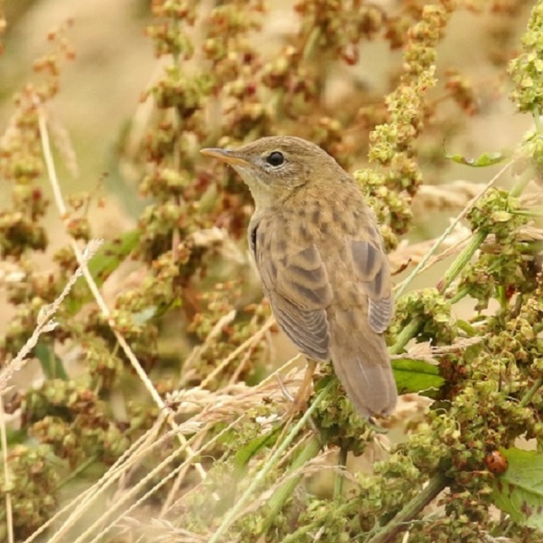
Whilst reading Dave Pogson’s great article on his local patch, some readers will be thinking what a lucky chap he is, and I too have reminded him of that but only ‘tongue in cheek’ I can assure you. He is fortunate only because he can walk out of his door, up the road a little and his daily work begins, many hours daily even, not to mention in all weathers of course. Only he knows exactly how many hours he puts in, but one thing is for sure, it’s a heck of a lot.
We are fortunate too as I don’t need to travel at all to cover my patch, in fact some days I can see quite a lot from the window or better still through the open kitchen door, which is only usually, though not always, closed when the weather is bad. Our garden was very bare when we moved in and wouldn’t have looked very tempting to passing migrants but now, after planting over 200 trees and bushes which form 2 hedges one of which connects our garden to Higher Green Owlers, where there is a stand of mature trees but shortage of undergrowth. We have also ‘cultivated’ a large patch of nettles, plenty of brambles, some gorse and heather, honeysuckle and plenty of grasses, sorrel,
Grasshopper warbler by Dave Sill
18

dock and many mainly wild ,plants and flowers. The word ‘weed’ doesn’t exist and even the large number of Dandelions on the ‘lawn’ are more than welcome (not that Monty Don would be impressed ). Given that we live at over 1,000 ft. on an open rather bare weather-beaten hillside we get plenty of insects, a good list of Butterflies and now the garden list of bird species is pretty good too. Both those taking advantage of the feeders or passing birds just dropping in.
The main advantage for me though is the view across the head of the Colne Valley and all that that brings, particularly when the conditions are favourable. South Westerlies are best, but not more than force 6 even with rain. Good numbers of Raptors are seen passing annually, the list of species is good and the list of 3 not on it just a dream. Lammergeier was one, I didn’t go to see ours, but I did wait with the scope pointed at the head of the Wessenden Valley for hours just in case it decided to move a bit further in this direction. Here’s to the next one. My favourite part, however, is counting Gulls as they fly past , sometimes very close sometimes not so. In the last 6 years I have counted just short of 30,000 as they moved W. How many slip by unnoticed is anybody’s guess and our weekly trip to Aldi alone must have had a massive effect on my counts, though I do try to put it off if conditions are right.
Of course, along the way there are always some surprises and my two biggest this year for different reasons are pictured.
A juv Grasshopper Warbler is the first seen and not heard here close to the house and sat absolutely still about 15ft. away for 30 secs., time to slowly reach for the camera. Just the opposite were two Dark Phase Arctic Skuas heading into a strong North wind which I almost missed, and the camera was under the wall out of the weather. Mad panic to uncover it and get some shots as
Dark Phase Artic Skuas by Dave Sill
they seemed to disappear more quickly than they actually did.
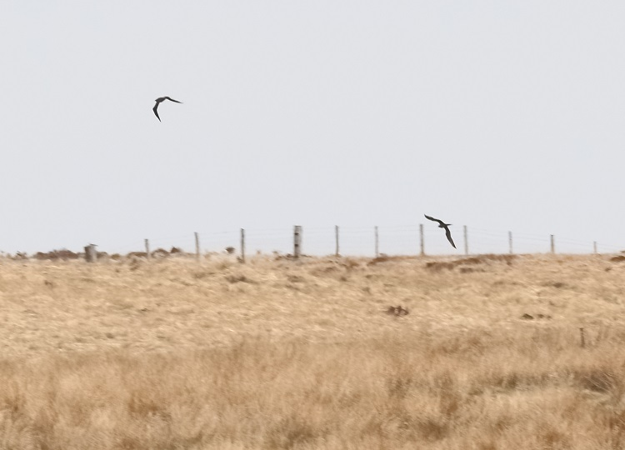
These are some of the ‘ups’. The ‘downs’ being, first having to dig probably 300 holes, the periods of Easterlies which bring very little past, periods of low cloud, of which we get many, particularly if they are in the Autumn migration period, with last but not least, blinding sunlight across the valley. Anyway, a glass to all you patchers and more power to your elbow.

19

The Members below
Are happy for YOU
To get in touch with them
To visit their patch.

Chris Abell has kindly volunteered and can be contacted by email; cdabell@gmail.com (preferred) or mobile 07929863115
Cheesegate Nab; well known as Ring Ouzel migration spot in mid-April, excellent for Warblers in Spring, breeding Lapwings and Skylark. Also, Autumn migration and winter Thrushes. Note that it can be very exposed particularly in winter
Langsett; varied habitat with lots of different walks/sites
Ingbirchworth Good most of year for variety of birds but early start needed to avoid too many dog walkers

Mike Denton has offered to show you and help you with birds currently at Blackmoorfoot Reservoir. This is a very popular meeting place for birders of all abilities and Mike in particular has been going there for many years.
His contact details are as follows 01484 646990 michael@atheta.plus.com

Dave Sill also offers to show you around his patch. The Wards End Farm area. Usually good for raptors and passing gulls. Also, small migrants from now onwards. Ring Ouzels, Wheatears in spring, anything possible! Refreshments will be served. Take into account that we do live in a remote area.
Just get in touch any day for more details: 07800937376 davidwsill@hotmail.com

20

Notice of AGM

The 55th Annual General Meeting is to be held in Huddersfield Town Hall at 7.30pm on Tuesday 2nd November 2021.

A full agenda will be published on the Club Website before the meeting.

The following posts are due for election to serve for 2 years.

- President

- Treasurer

- Indoor Meetings organiser

- 3 Committee Members

Nominations for these posts should be sent to the Secretary, in writing or by email, 14 days before the meeting (i.e., to be received no later than 19th October).

Please note that in the current situation regarding Covid-19 it is unclear whether the meeting can be held as planned. Please check the website, forum or contact the Secretary for up-to-date information

21

SUBSCRIPTIONS AND CONTACT DETAILS

HI ALL,

I AM NOW IN THE GUISE OF MEMBERSHIP SECRETARY!

IF YOU HAVE ANY RECENT CHANGES TO YOUR CONTACT DETAILS E.G. ADDRESS, PHONE NUMBER OR EMAIL WILL YOU LET ME KNOW. EMAIL ADDRESSES ARE PARTICULARLY IMPORTANT AT THE MOMENT. I NOTICE A LOT OF MEMBERS HAVE LANDLINE PHONE NUMBERS AND NOT MOBILE WHICH IS FINE, BUT IF YOU JUST HAVE A MOBILE NOW WILL YOU LET ME KNOW.

THIS YEAR AS YOU WILL SEE WE MAY NOT BE HAVING INDOOR MEETINGS BEFORE CHRISTMAS, CONSEQUENTLY I AM ASKING IF YOU WILL KINDLY SEND IN YOUR SUBSCRIPTIONS:

Single £19 couple £30

If possible by bank transfer to our HSBC account:
Sort code 40-25-10
Account number 40462195
Huddersfield Bird Watchers Club

Or by cheque to:-

Hazel Sill, (membership secretary), Wards End Farm, Marsden, HD7 6NJ
hazelsill@hotmail.com 07854739646

22
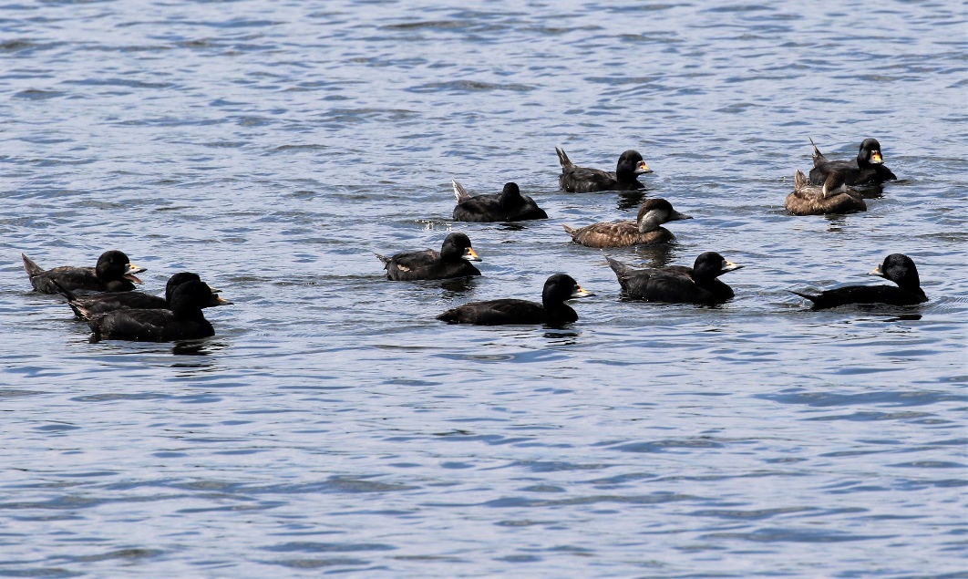
Spoonbill at Horbury by Nick Mallinson
Common Scoters at Ingbirchworth by Nick Mallinson

