**England Twite Recovery Project Update, December 2022**

**By Katie Aspin, Twite Project Manager**

**Hello and welcome to the 2022 Twite Recovery Project Newsletter**

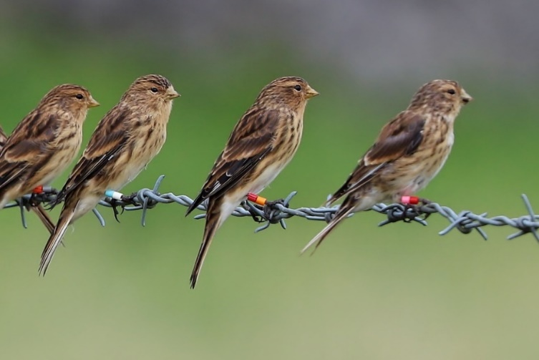I would like to update you on the work we have been doing this year, and on all the exciting things we have planned for next year. Firstly, I want to start by giving a bit of background to the project and why it’s so important.

**Twite and the recovery project**

Twite are hardy seed eating finches that live in remote upland and coastal areas, mainly in Scotland, but with small numbers in North Wales, Northern Ireland and the Pennines. In England, they were once a common sight in the Pennines, so much so that they gained the nickname of Pennine Finch. However, over the last few decades they have undergone dramatic declines, with a 72% decline recorded between 1999 and 2013 in England and further declines since. The reasons for the decline are complex but include a lack of breeding season food availability and optimum nesting habitat.

*Image by Peter Welch*

The England Twite Recovery Project (ETRP) was set up in 2008 as a partnership between RSPB and Natural England, with the main aim of halting this decline in twite abundance and range. During this time, the main focus of the project has been on increasing breeding season food availability. Project staff have worked with upland farmers in the South Pennines to restore and improve hay meadows and pastures, increasing key twite food plants, including Dandelion, Common sorrel, Cat’s ear and Autumn hawkbit.  This has all been funded through NE agri-environment schemes.  Nearly 700 ha of land has been managed to benefit twite through these schemes, and over 250 ha of land has been reseeded with key twite food plants. The project has also trialled various new methods to fill twite breeding season food gaps, including a hay strewing trial, planting autumn hawkbit plug plants, heavy grazing trial to increase dandelion abundance and setting up supplementary feeding stations.

However, despite all this work, twite have continued to decline in the South Pennines, and the 2021 survey of 18 monitoring sites found only 12 breeding pairs at 5 sites.   A change of approach was needed, so our Conservation Science team completed a new piece of research using the twite population data which we have collated over the years. This research highlighted two key parts of the South Pennine twite life cycle which we needed to focus on to stabilise the population:

* **Nest productivity** – not enough nests are successful and not enough young are fledging. We think this could be due to nest predation.
* **Juvenile survival** – not enough juveniles are surviving their first year, whether in the post-fledging period, during migration or on the wintering grounds.

Following these results, a new 3-year project proposal was developed, which started this breeding season, focusing on nest protection and increasing knowledge of predation risk on breeding grounds, reviewing breeding season food availability interventions, continuing to fill food gaps via feeding stations and keeping up to date with the population status through repeated population monitoring.

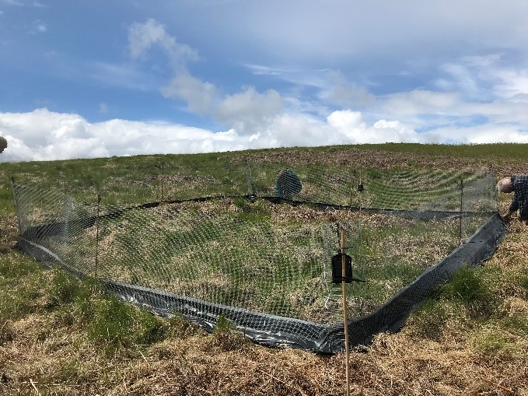**Work completed in 2022**

***Nest Protection Fences –*** Our aim was to fence off twite nests to protect them from mammalian predators, principally mustelids – no easy feat! We developed a design over a number of months and, with the help of a group of practical conservation volunteers, placed the fence around a twite nest. However, the adult twite would not fly over the fence to return to the nest and rejected the fence on two separate occasions (thankfully, the nest went on to fledge successfully). We’re therefore working on updating the fence design to try again this year with larger enclosures to reduce disturbance to the nests. Watch this space!

*Nest Protection fence on site*

***Predator Surveys –*** We started monitoring for potential twite nest predators at one of the key twite sites, something which we have not done before. We completed fox scat transects, corvid surveys, and put out footprint trackers and trail cameras on animal tracks. We found evidence of foxes, stoat, weasel and various corvids at this one site. This small-scale survey will be scaled up next year to allow us to gather data on predator presence and abundance.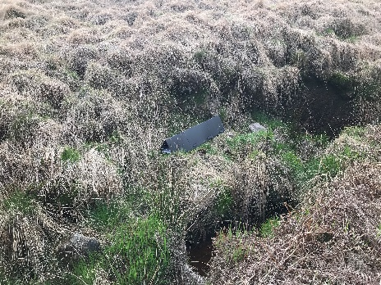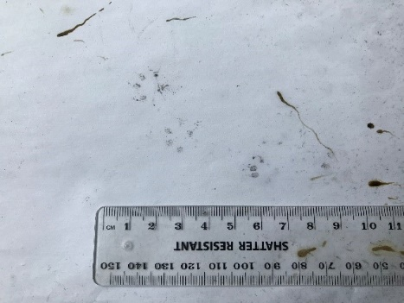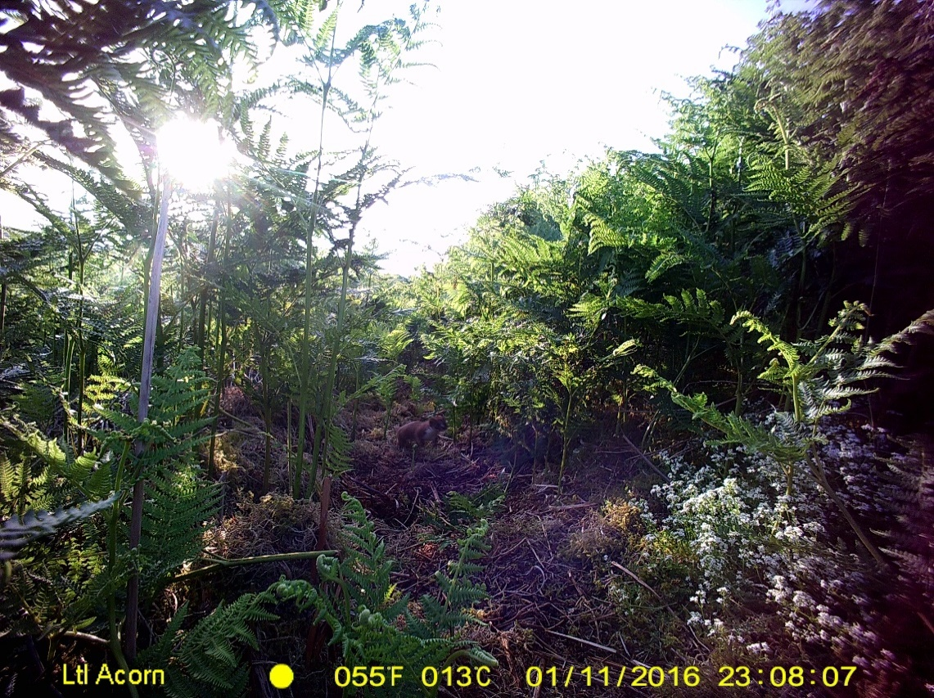

*Footprint tracker on site, stoat footprints found in one of the footprint trackers and a weasel caught on one of the trail cameras.*

***Feeding stations -*** We had a total of 10 feeding stations running this year, with the aim of filling breeding season food gaps.  They are run entirely by volunteers, who visit the feeding stations at least twice a week to put fresh seed out and to spend an hour monitoring, recording twite and other bird observations and collecting colour ring data.   Seven feeding stations have been used by twite this year and volunteers have made hundreds of observations and collected information on 48 different colour ringed birds. Unfortunately, not all these birds stay to breed in the South Pennines, with a winter flock coming in from elsewhere, possibly Scotland, but then leaving before the breeding season. All this valuable information will be written up in a report comparing to last year’s records and will be used to help us to learn more about twite movements in the South Pennines and beyond. Massive thanks to the feeding station volunteers, you do an amazing job!

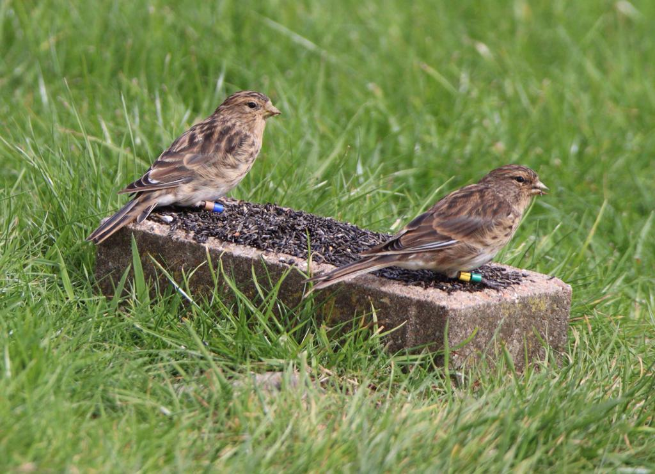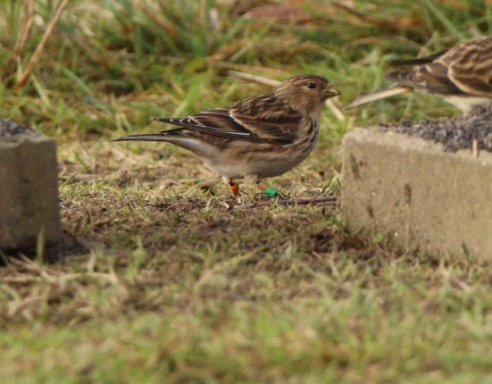

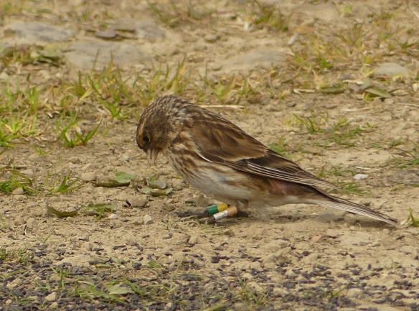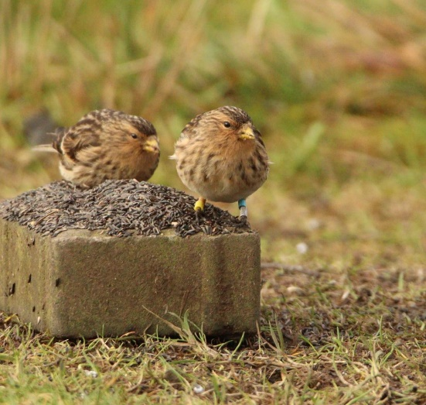

*Colour ringed twite at feeding stations – Photos taken by Rod Jones*

If you’re lucky enough to see one of the colour-ringed twite, please send me details of the 4-ring combination for our records.

***Monitoring***

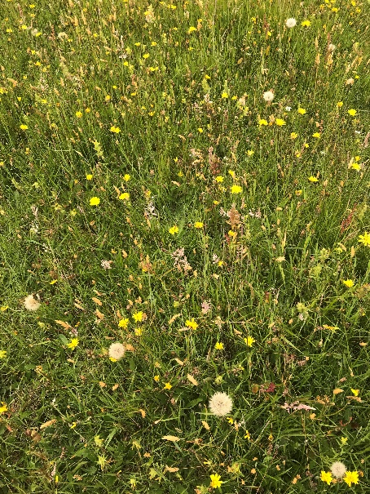Breeding bird survey –we completed a full breeding bird survey at one site and found that the estimated number of pairs had remained the same as in 2021 (5 pairs). We also found 5 twite nests at this site which we monitored, with 2 nests successfully fledging, but unfortunately 2 nests were abandoned and 1 nest was predated. We plan to do more nest finding work at more sites next year as part of our nest protection work.

Meadow monitoring – we have regularly monitored the restored meadows and pastures as part of the project to see if the twite food plants are growing well. This year we re-monitored over 100 fields and offered advice to farmers on ways to improve the meadows through tweaks to management. As always, please do get in touch if you need advice on meadow management for twite.

*One of the reseeded meadows in full bloom*

Autumn hawkbit monitoring – as part of our aim to increase late breeding season food sources for twite, we have planted over 9000 Autumn hawkbit plug plants across 13 sites since 2017. This year we went back and monitored these sites to see if the plants had survived. At the majority of sites the Autumn hawkbit were growing well, fantastic news for hungry twite!

**Upcoming work for 2023**

2023 is going to be a very busy year for the project and for our mission to stop twite from going extinct in England. We will be continuing with our emergency measures approach with the key work including:

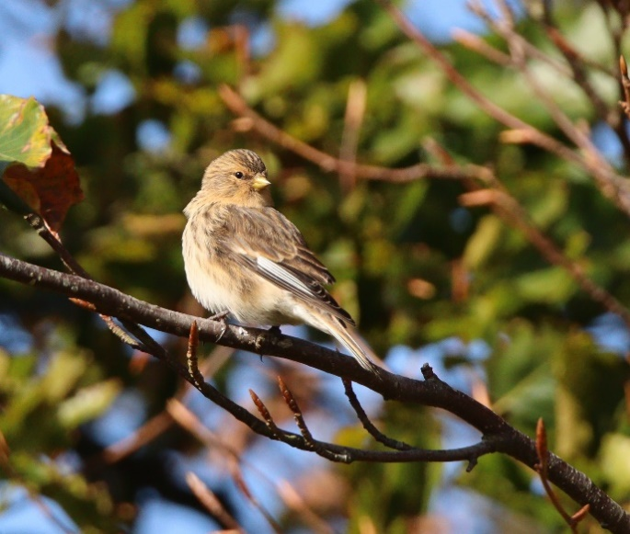***Nest protection –*** We plan to continue with this work, fencing off as many twite nests as we can find with our mammal proof fencing to try to reduce nest predation events. We will also expand our predator surveys to collect data on predator abundance on twite nest sites which will inform our conservation work. We have our fingers crossed that the twite will accept our updated fence design! We need more volunteers to help with this work, so if you enjoy practical conservation work please get in touch.

***Feeding stations –*** Feeding stations are key in the short term to make sure twite have enough food during their breeding season. We will therefore continue to run the key feeding stations to fill the breeding season food gaps, monitor for twite and collect colour-ring data.

***Image by Rod Jones***

***Annual breeding abundance monitoring –*** with such low numbers of twite, it is key to have up-to-date knowledge of how many breeding pairs are left each year and where they are nesting. We will therefore do a full twite breeding bird survey at all our 18 monitoring sites. This data will help to inform where we focus our nest protection work.

***Monitoring of restored meadows/pastures –*** we will continue to re-survey a sample of the restored meadows/pastures now that a good amount of time has past since they were restored. We will analyse the data to find out whether this intervention work has been successful or whether further work is needed.

***Twite transect surveys –*** we will collect data on where twite are feeding and whether they are using the feeding sites set up by the project (restored meadows/pastures, feeding stations, Autumn hawkbit planted areas) as a way to evaluate the success of our feeding intervention work.

***Farm advice –*** we will continue to offer help and advice to South Pennines farmers on twite land management and agri-environment schemes.

***Raise awareness and support from local groups and key stakeholders –*** we will raise awareness of the massive challenges facing twite and drum up support from local groups and key stakeholders.

This work is all subject to funding, we are in the process of securing the funds and recruiting the staff necessary to begin this work in April 2023.

To do all this work we need your continued help and support, whether that be as a farmer managing your meadows to make sure twite have plenty of food to feed their chicks, one of the 22 volunteers who have given up your free time to help us to monitor the feeding stations or put nest protection fences up, or a stakeholder making sure your staff and contacts are aware of twite and their habitat requirements.

**We really appreciate your continued support of the project! Thank you for reading and I wish you a Merry Christmas and all the best for the New Year.**

***For advice on land management for twite, to find out more about volunteering for the project or for further information please contact -***

Katie Aspin, RSPB Twite Project Manager (phone - 07736722177, email - katrina.aspin@rspb.org.uk)

**With thanks to our partners**



If you’d like to change how you hear from us or you no longer wish to receive this publication, it’s easy to do. Please call Katie Aspin on 07736722177, or e-mail: katrina.aspin@rspb.org.uk.  **Please get in touch if you would like to help us save paper and postage costs by receiving this yearly newsletter by email.** For more information about how we use your personal data, and your rights please see: www.rspb.org.uk/privacypolicy