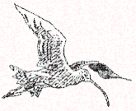
HUDDERSFIELD
BIRDWATCHERS’ CLUB

NEWSLETTER
2022
Registered Charity No. 1098296

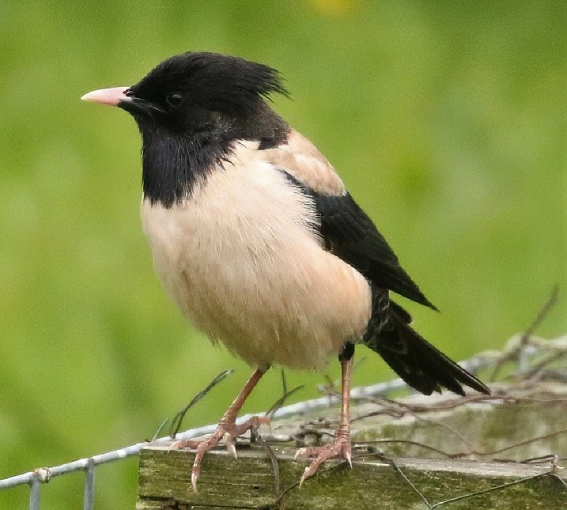

Front cover: Rose-coloured Starling by Dave Sill
CONTENTS
THE PRESIDENT’S NOTES | 3
OUR PRECIOUS MOORLANDS | 4
REPORT RAMBLINGS | 6
SIGHTINGS | 7
OUR SPEAKERS THIS YEAR | 8
ROSE COLOURED STARLINGS | 10
A WELCOME BACK PIED FLY CATCHER’S | 11
URBAN PEREGRINES | 12
RIVER HOLME CONNECTIONS | 14
REPORT ON DEAN WOOD 1967 | 15
NOTICE OF AGM | 17
SUBSCRIPTION DETAILS | 18
ANNUAL REPORT 2021 | 19

In Focus Denby Dale, open
Thursday, Friday, Saturday, 10am-4pm

THE PRESIDENT’S NOTES
The end of June is fast approaching, and I am still recovering from the 3-day visit of the Rose-coloured Starling to our garden, which I’m happy to say was seen by over 20 people despite the inaccessibility of our house. If there’s one thing about this game though, it is that you never know what’s around the corner, or even just over the horizon. I now take back all those unkind things (some unprintable) I’ve said about the hundreds of Starlings (the Common sort) that sometimes descend on our garden like a plague of locusts.
Work is well underway on the 2021 Annual Report and on course to be ready for the new season. Talking of reports and records, much has been said and written on the subject over the last year or two and if I may I’d like to add my two-pennyworth.
It’s easy to forget that although we are a bird club we are also a charity. With this status come some advantages, these are mainly financial and are obviously welcome and important to us. On the other hand, though, there are conditions, which we are legally obliged to follow. We have to have a constitution which states the aims of our Club, with probably the most important one being, ‘to study and record the wild birds of the area and publish an Annual Report.’
This the Club has done ever since 1967, in which year the Report consisted of 20 pages from 27 contributors. We have come a long way since then and our last Report in 2020 contained 156 pages from 98 contributors. The report now contains much more detail about the birds in our area and usually we receive c.1,500+ records per annum. We do need this number and even more if we are to continue with our present standard of report. The problem we are having at the moment is that not all the afore mentioned records are useable, in the sense that they contain little or no useful information (though often plenty of words), and this could be as many as 10% of them ( I haven’t done an exact count). Many species are ‘overlooked’, even ignored, which shouldn’t be happening in such a publication as this. Every Recorder I have known has wanted as many records as possible, and that doesn’t change, everyone is important and now is no different so please ! keep them coming in and more, but please make them mean something and we will be able to continue into the future with a meaningful and valued Annual Report.
Right, onward and upward. Apart from the Annual Report progressing, thanks to Dave Brierley, as you will see enclosed, we have a full complement of guest speakers covering a wide range of subjects for the coming season and we hope you will support them.
The survey we have undertaken at Tunnel End, Marsden is still ongoing and will be for some time, so everyone is welcome to take part, the more the merrier, just send your records to Mike Pinder at pinder.uk@btinternet.com
This site has much potential as past records show, and one or two things have been seen this year too. Mike is collating these, and his work will be published in the Annual Report.

I was saddened when Nick Mallinson told me he was off to pastures new. The fact that he told me whilst we were watching the Rose- coloured Starling only made it slightly more bearable. He has been a member for many years, served on the committee and took on the duties of Treasurer and then Recorder. He was a member of the Harden Visible migration team and apart from all that he is also a nice bloke. Other than finding some good birds he also sent in many records each year and the missing (NWM) will leave a massive hole, both in our Report and in our Club. He will be a hard act to follow but we wish him and his wife Michelle a very happy future in Northumberland and our loss will be some lucky bird club’s gain.

(3)

OUR PRECIOUS MOORLAND

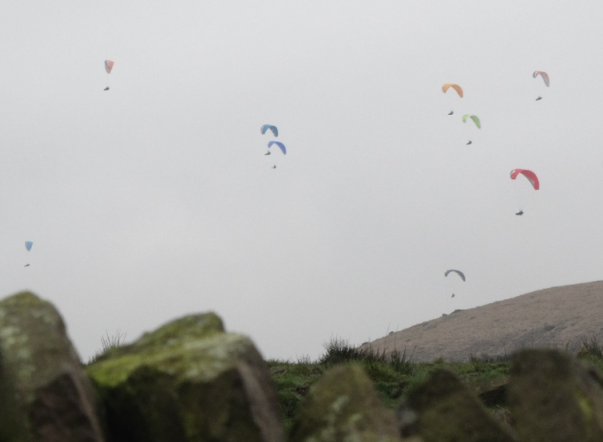
We are very lucky to live where we do, there are some down sides, but we can just sit and look over the moors across the Colne Valley towards Pule Hill, Redbrook Res. and beyond. I was doing just that on the last evening of the recent heatwave, sitting in the garden nothing bird-wise so I just took one or two photos. The thing that surprised me the most was the number of cars parked on the A62 at Redbrook Res. We are used to seeing vehicles parked there but this time I counted at least 62, why you may ask? Well, it’s a nice place to walk with the dog, but that’s not all. It is becoming more and more popular to go for a swim there, it’s very busy and not just in summer. The fact is it’s yet another way of people disturbing the wildlife without any thought or care. We have witnessed many moorland fires at close range, usually started by barbeques, cigarettes and even fireworks. Everything imaginable takes off and hangs around Buckstones Edge, a fantastic place for many passing and feeding raptors when there is the prevailing SW. Quad bikes, scrambling bikes, many, many dog walkers, particularly the ‘professional’ ones with up to 12 of other people’s dogs, people who shouldn’t really have a dog. Everything that is inflatable comes our way from Manchester on that same SW wind, countless party balloons (probably similar to the one that scared Dave Pogson’s Great Grey Shrike away a couple of years back) and other tasteless rubbish on a regular basis. Walkers who just throw empty bottles and rubbish everywhere. All add their bit to what has become a constant and increasingly big problem which the authorities seem helpless to deal with and are even encouraged to turn a blind eye to. One thing is for sure, some of our moorland reservoirs are not much use for breeding birds anymore and even the most remote ones are no longer out of bounds. Species like Little Ringed Plover and Common Sandpiper that prefer to nest on or close to the shore are the most disturbed, but even ones like Redshank and Oystercatcher, Curlew, Dunlin, Golden Plover and others where a fire at the wrong time can cause devastation. Not to mention the ground nesting passerines. We have been here for just about 20 years now and the difference between then and now is staggering and getting worse.
When we moved here we had Little Owls just down the hill from us but because of disturbance from neighbours they are gone, no Lapwings now that used to nest in the fields to the right of us where now stands a horse-riding ring, which was a waste of space as it was only used twice. Cutting the fields at the wrong time and the general lack of knowledge put paid to them and some spring passage Wheatears too. We had 5 pairs of Curlew nesting nearby, perhaps one this year. No drumming Snipe this year either, that fantastic noise in the evening. Hopefully to return one day.
(4)
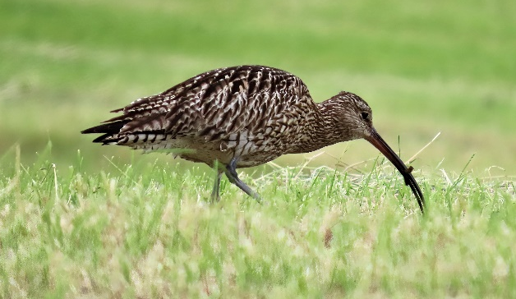
Photos by: Daves.
Pennington
Pogson
Sill.

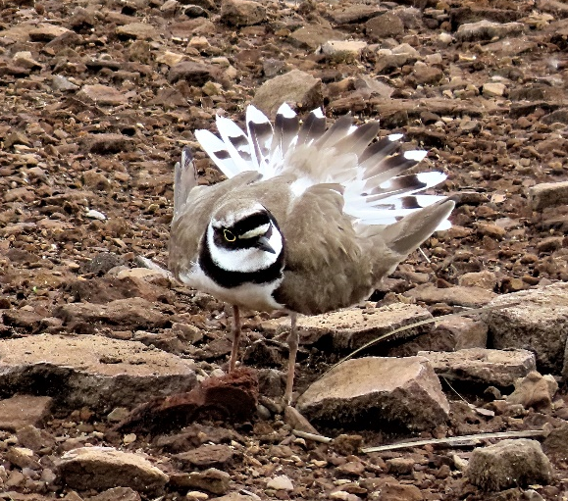
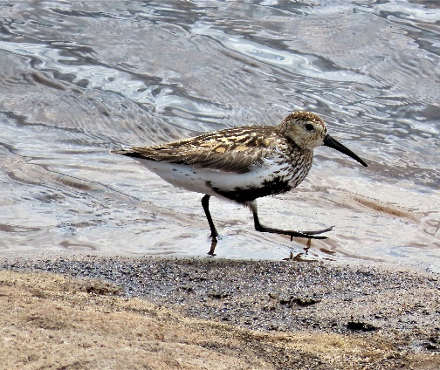
REPORT RAMBLINGS
I’m not quite sure how I became involved in helping to write the 2021 Bird Report though I do remember saying to Dave that I used my desktop to put together my observations and this allowed me to do some simple analysis. This must have qualified me as being Computer literate and an obvious candidate.
Initially I was sent the pro forma for five or so birds along with the records and following the format of previous years it was a straightforward task to outline numbers, dates, places and relevant details of breeding, migration or movement including night sound recordings and to pen a report. This task was made even easier by the interesting comments which many observers include with their observations. The first few did not take very long to do, and I was quite happy to tackle more though I knew as I was about to travel to France I would be restricted to an iPad which did pose some difficulty as the cursor seemed to have a mind of its own. Certain birds did require more time than others, first reading through the reports, and then fitting the information into the format which hopefully allows trends to show up more clearly. It has been an interesting experience which I have enjoyed on the whole though the tradition of using superscript for dates can be a rather frustrating task on a 9” iPad.

Being naturally curious I could not help but play with the filter and sort buttons I found on the programme to interrogate the records. This allowed me to see who sent in the most records for a particular bird and where a bird was more likely to be seen. It was also simple to work out when the first and last birds occurred or the highest concentrations. I was also curious as to the distribution of some of the observations across the area which also showed up where the observers did their observations, some birders being more itinerant than others.
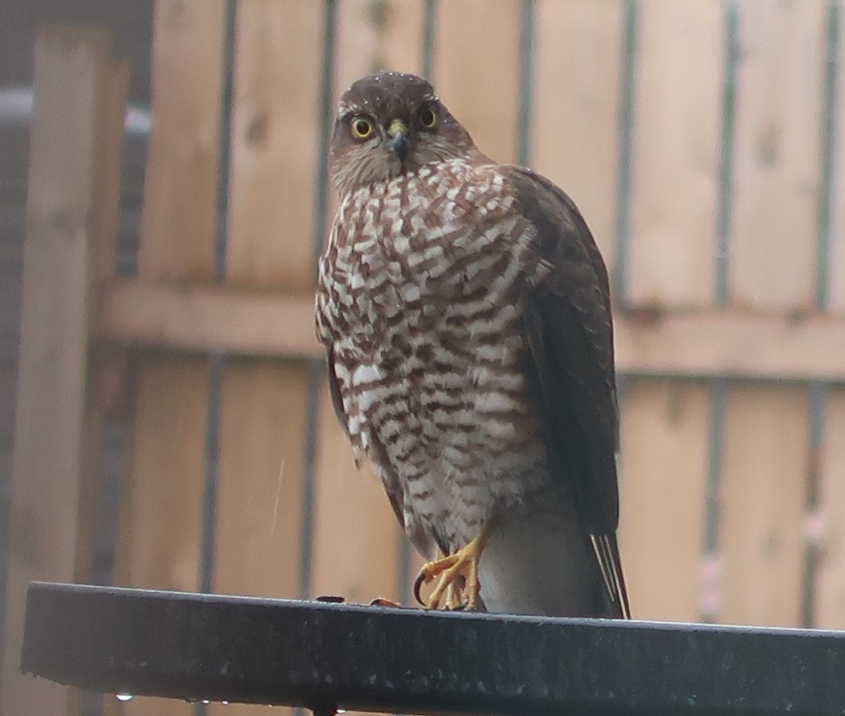
The reports also showed differences in how people record their observations whilst some records are very detailed others are more general. When I first started to take my observations more seriously I

(6)

knew it would be too time consuming for me to do what is suggested in most books. I also knew I would lose paper records so I decided to use the notepad on my phone and follow the RSPB bird watch principle at home but not limit it to one hour. Using BTO abbreviations I note maximum
number, sex and any other relevant detail such as breeding or direction for each bird, 6HS-mmfjjj tells me I have seen a maximum of six House Sparrows, two male, a female and three young. This is
shared by email to my desktop where it is pasted into a worksheet and with the press of a button and some checking and tidying it can be sent to the recorder with the abbreviations written in full. I have also used two apps when I am out and about, “ebird” an American app which will allow you to email it immediately to the recorder or a friend if you so wish and Bird Track, a BTO app which only allows you to share with the BTO. Whatever method an observer uses it should provide the basics and be best suited to the observer. Today I saw a young Sparrow Hawk appear from behind a bush circle the bird feeder twice in less than two seconds and disappear between two bushes in pursuit of the Sparrows that had been on the feeder, only to reappear seconds later on the lawn with a Sparrow in its tallons; it has gone down as “SH-mj killed HS”.

One comment noting that a particular species seemed less numerous in the last half of the year in their area made me curious enough to do a count of numbers reported in the first and last six months. Over the Huddersfield area from the numbers reported there were more records in the last half but there are too many variables to suggest why that may be the case but that does not detract from what was a perfectly astute observation. It also steered me to an inquiry as to how the BTO arrived at their figure for the distribution of species. A cursory search suggested to me that rocket science would be child’s play compared to the variables that the statisticians have to consider, nor are there enough nasty wet days for me to spend on the computer to want to revisit the idea. We can only record what we see and where we see it. It is not surprising that many observers want to see the less common or “more interesting birds'' and that they travel to the locations which give them the best opportunities, whilst others are happy with a patch, or their back garden. This is where most birders derive their pleasure and satisfaction whilst others may wish to take it further into the science.
,
Our report is not a complete study or survey of every bird similar to the detailed articles on the Rook population, the Crossbills of Harden Quarry or The Birds of a New Mill garden. Every effort is made to ensure the observations supplied are presented as accurately as possible following conventions set out by the BTO and YNU. What is clear is that we are doing interesting, valuable work that other organisations appreciate and value and for that reason I feel we need to thank all those who do take the time and effort to record and forward their observations in whatever form.

John Parkinson

SIGHTINGS

Thought this small table would give some guidance to our less experienced birders, as to what information we need, you don’t have to be a member to send in sightings, but it is good if you are! ED.
SPECIES | DATE | WHERE | NUMBERS | BREEDING | COMMENTS

(7)

OUR SPEAKERS THIS YEAR – David Brierley

2022
6th September Ian Newton
We welcome back Ian who was last here in our 2014/15 season. This time he will entertain us with his talk Ecuador Birding Heaven.

29th September John Cranmer
John is relatively new to the speaker circuit; he is based in Wakefield and has not been to HBWC before. He will be coming to speak to us about his travels in Golden India.

4th October Paul Hobson
Paul is a well-known photographer and speaker, he has won a number of prestigious international awards, including commendations in the “Wildlife Photographer of the Year” and “European Wildlife Photographer of the Year”. Paul will talk to us about Coast and Island.

18th October Reg Senior
Reg has entertained us on numerous occasions before with an excellent array of interesting talks. He will captivate us again this time talking about Wildlife over a year on a Grouse Moor.

1st November ANNUAL GENERAL MEETING Followed by:-
David Brierley
David will be doing his third talk for us. This time he will be talking about his visit to India, which includes culture and wildlife as we travel with him across this unique country.

15th November John Gardner
John is a well known wildlife photographer in Yorkshire and he also travels to more exotic places following his passion for wildlife photography. He is an active member of Wakefield Natural History Society. John will be speaking to us about Yorkshire Wild Beauty.

6th December Mark Pearson
Mark is a well-known speaker who has also featured on “Springwatch”, “Autumnwatch” and “Natural World” as well as speaking at the “Bird fair” (now “Global Bird fair”). He will be speaking to us about Seaducks.

(8)

2023
10th January Linda Jenkinson
Linda is the founder and owner of Start Birding and is based in Leeds, she has a lifelong passion for the natural world. She also teaches people about Birds and has extensive knowledge of places to watch wildlife, both locally and further afield. Linda will talk to us about Yorkshire Birding.

24th January Professor Alistair Fitter CBE
Alistair is a Professor of Biology at the University of York and is the son of naturalist and author Richard Fitter. He was elected Fellow of the Royal Society (FRS) in 2005 and was appointed Commander of the Order of the British Empire (CBE) in 2010. Alistair will be speaking to us about the state of nature in Yorkshire.

14th February Ron Marshall
Ron resides in Barnsley and has been a serious birdwatcher for 35 plus years. On retirement he developed an interest in photography which in turn opened up the gateways to travel. Ron will speak to us about Alaska.

28th February Gordon McMinn
Gordon is employed by the Canal and River Trust and operates from the Tunnel End Centre at Marsden. His talk will be about conservation and restoration.

21st March David Tolliday
David has been to our club a number of times before. He is a keen wildlife photographer and is based in Cheshire. David will be speaking to us about Costa Rica.

11th April WPC Caroline Newsome Wildlife Crime Officer
Caroline holds the position of Wildlife Crime Officer within the local police force. Her area covers Kirklees and the Derwent Valley, she has also helped locally in the Peregrine project.

25th April David W. Sill
Our President David will close our season by giving us a thorough insight of the birding year with photos from members and other local birders. An informal meeting that Dave hopes everyone will join in. This is the last meeting of the season.

(9)

ROSE-COLOURED STARLING

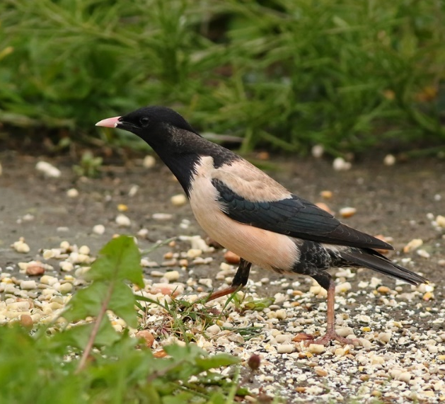
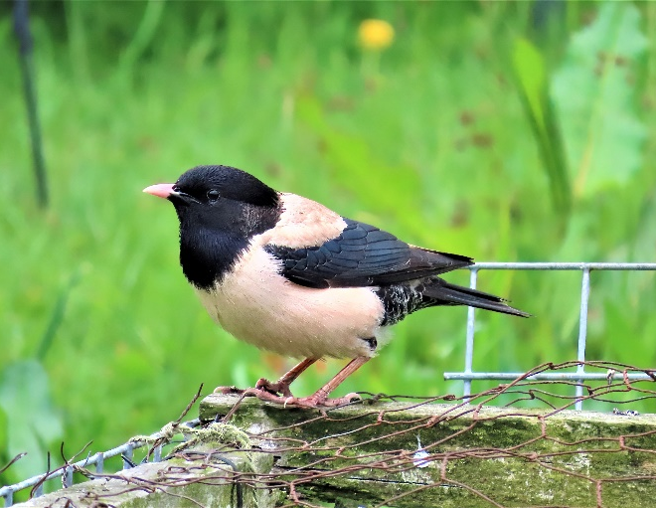
Nine o’clock on Sunday 5th June and with a force 3 Easterly wind with heavy rain at times, didn’t look particularly appetising. However, our terrier thought otherwise, so during a lull in the rain we set off down the yard. From under the neighbours barns I can get a sheltered view across the fields and up the valley, whilst the dog happily rummages around in the hay. The rain was too heavy even for that, so I opted for sheltering in the shed/hide I have in the field which overlooks the valley. I had been there for a couple of minutes when a few Starlings flew low across the front of me and I immediately saw that one was a ‘pink one’ and it landed in the field some 70yds away, which enabled me to get one or two ‘record shots’. I rang Hazel, told her what I’d seen to which she replied “I know I was just about to ring you! I’ve just seen it on the feeder outside the kitchen window”. I then sneaked into the garden, and took another couple of photos. I had to make some phone calls to make sure others could see it and put a photo on the Forum too, hoping club members would pick it up and it would hang around for a while. Dave and Steve Pogson, Dave Pennington and Nick Mallinson soon arrived and reasonable photos were had by all. However, as it kept returning to the garden, the rain had lessened so we stood in a corner there. For the next hour or so it continued to visit the garden for quite lengthy periods down to no more than 10 yds away. It continued to behave in this same manner until it was last seen around 16.00hrs. on Tuesday 7th.
Dave Pogson
Dave Pennington
With rare birds it’s often a case of ‘blink and you miss it' in this case it was definitely ‘blink and you see it’ . A good number of people got to see it, and only one person who came missed it. We managed not to block the track too, which the folks on the hill wouldn’t have been too pleased about.
Here’s to the next one!

(10)
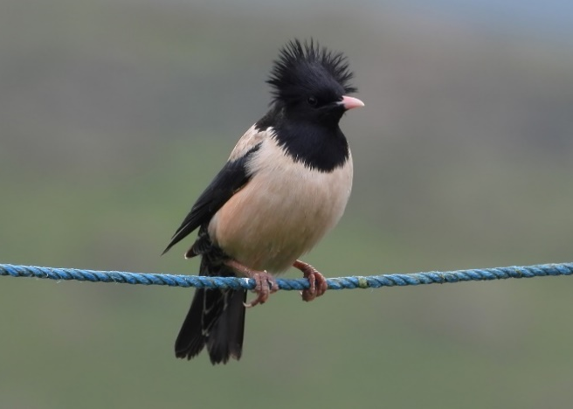

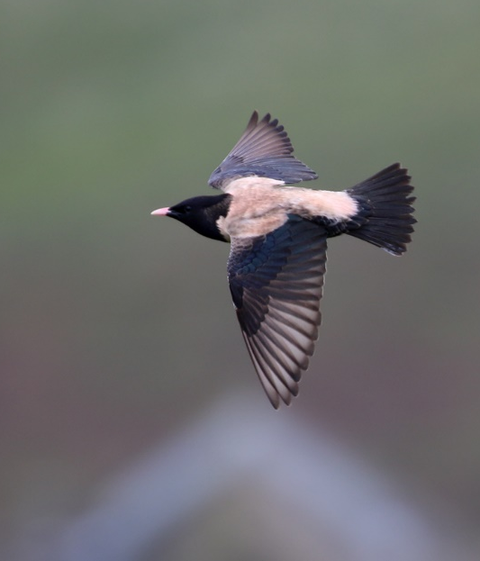
Rose-coloured Starling is an irruptive species breeding on the steppes, agricultural land and semi-desert from central Turkey east as far as Afghanistan and Kazakhstan. Spring and early summer tend to see overshooting adults with post breeding juveniles in autumn. As is the case with species such as these numbers can vary immensely from year to year with this year’s records coming from just six English recording areas. We have now just had two in two years in our area with the only other one in 1859. Inland, quite often they are attracted to gardens by the Starlings
Steve Pogson

Dave Sill
Nick Mallinson

WELCOME BACK PIED FLYCATCHERS
By Dave Pogson

On Bank Holiday Monday the 2nd of May, I decided to walk up to Windy Bank Dam to see if the pair of Common Sandpipers I had seen a few days earlier were still present. I hadn't gone far into the wood up the main track that leads up to the Dam when, amongst the usual singing Chiffchaffs Nuthatches and Blackbirds, I heard a distinctive jerky, repetitive bird song that I instantly recognized as the typical song of Pied Flycatcher. I hadn't heard or seen this now Red Listed species at this site since the early 90's so I was both pleased and surprised in equal measure .
I soon located the bird through binoculars. It always stayed high up in the quite leafy canopy and was quite hyper-active in its feeding but stopping every few seconds to give its jaunty, two-second-long song.
I knew a few birding friends who would probably be interested in seeing it so, the next day I met my good friends Keith and Yvonne Horne and we soon heard the male singing in the same area. Yvonne, to her credit, then saw a female join the male briefly. This seemed very promising.
I let a few more birding friends know about it including Dave Pennington, Tim Duckworth and Mary Walker, my brother Steve was away on holiday at the time so there was no point in phoning him.
A couple of days later I had a call from Tim letting me know he'd seen both male and female
(11)

Flycatchers together and the female entering a likely nest site. This was in an old Great Spotted
Woodpecker nest hole that had also been used by Nuthatches at some point. The nest tree was quite close to the footpath but not easy to see.
I decided to visit the site most days to see if I could prove successful breeding.
Over the next week or so the birds were very secretive, and the male had all but given up singing. On the 23rd of May it was obvious that they had young, with both birds bringing in small green caterpillars and insects at regular intervals. In the first few days the male was bringing in items more regularly than the female, but this evened out as time went on with the female remaining inside the nest cavity for longer periods than the male.
Even during inclement weather with periods of heavy rain and blustery winds the pair 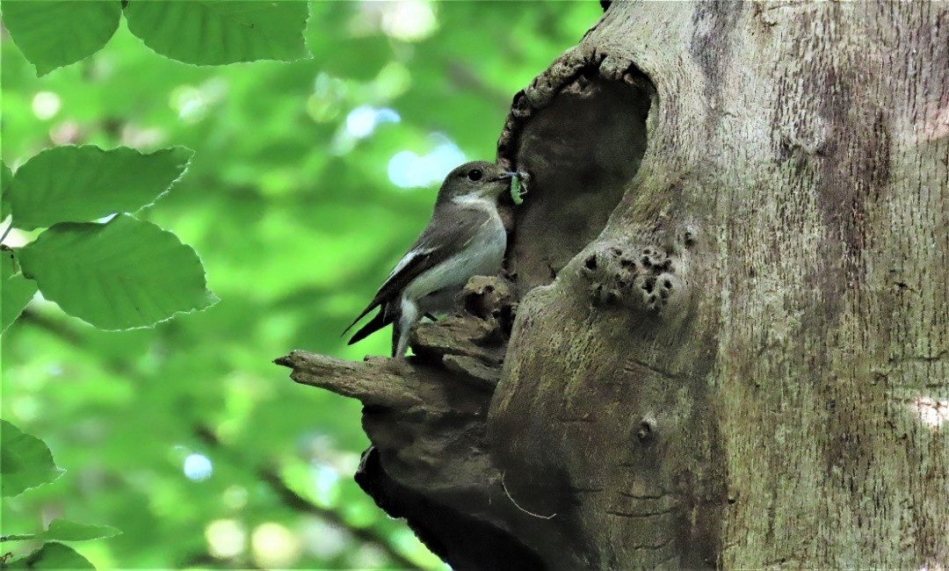didn't seem to be having any trouble finding enough tucker for the young.
The only thing that seemed to cause them concern was when a Jay or Squirrel appeared, then they wouldn't approach the nest but persistently gave the piercing loud alarm call till the perceived danger had passed.
By the 8th of June the young were on the verge of fledging and were now seen poking their heads out of the entrance.
Next morning, they had obviously left the nest, but the adults were seen briefly in the now dense canopy above, carrying food and giving occasional alarm calls. This was very satisfying to watch, especially it being a natural nest site, much more satisfying than being in a nest box with a number painted on it.
It was because I spent so much time watching this site I became aware of other nesting birds in a relatively small area, these included Great, Blue and Coal Tit and Treecreeper that I might otherwise have overlooked.
I would like to thank my good friend Tim Duckworth for putting his nest finding skills to good use.
All this site needs now are the Wood Warblers and Redstarts back.

Dave Pogson is one of our diligent and knowledgeable members and spends a lot of time watching birds particularly in the Meltham area. He has also written quite a few articles for our Newsletters, and I use his photos quite a lot too, as you will see above. Ed.
(12)

Urban Peregrines.

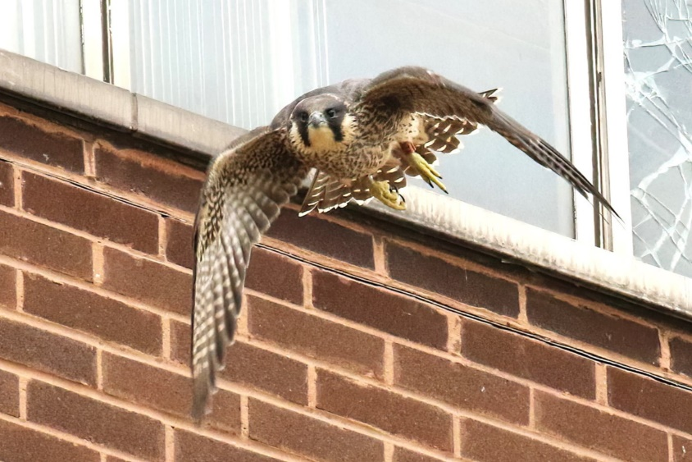
After reporting the progress of our two urban nests last year we are happy to say that we now have a third one. This year the two existing ones have successfully fledged three and two young, and the new nest two. After the problems that initially occurred at one of the nests we are glad to report that there were no further difficulties, and all has gone well. All three nests are in locations which are as safe as we could wish for and hopefully will continue to thrive and up to now at least 16 young have fledged from these nests, and of course the ready supply of pigeons always helps.
Mick Mail
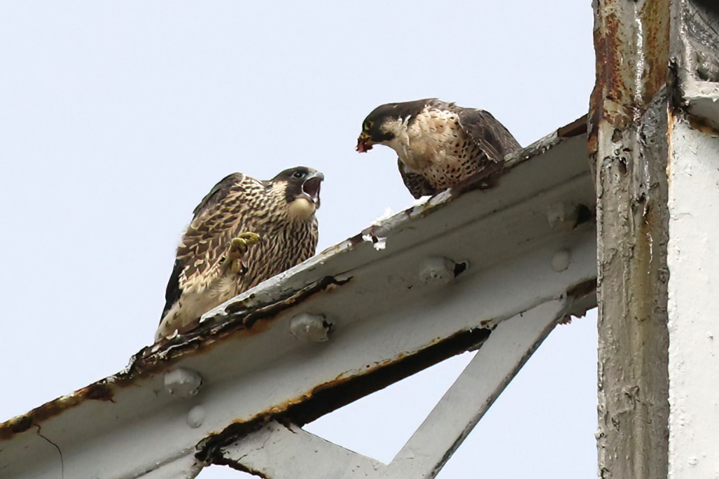
This trend continues nationally, and it doesn’t mean to say that we won’t get more, space and food permitting so keep looking upwards onto those chimneys and tall buildings, you never know. Meanwhile have a look at some of the present ones thanks to Mick Mail who keeps a constant eye on them (as well as a lens) and we will keep you updated.
Mick Mail
Dave Sill (13)

RIVER HOLME CONNECTIONS
By Steven & Heather Chippendale

What dreadful weather, the wind is howling through our extractor fan and the rain is battering on the windows, oh no…this is really bad, today is the day we are helping lead a group of people on the Lockwood part of the river Holme to show them what birds there are. No one will come! Why would they on a day like this! Still we have to get ourselves ready, as we expect Chris will be waiting for us outside Grappolo’s café probably thinking the same as us, that we should be going on a better day.
Stephen and I walked down to Lockwood, and across the road we could see Chris and one or two cars parked.
Slowly people started to arrive all dressed in their appropriate winter clothes and boots and before 9 am twenty people had arrived, Wow! Stephen said that it wasn’t the best sort of day for seeing wildlife and that the birds would probably be hiding out of the way, but nevertheless the walk would be pleasant and he would tell them something about the wildlife we had encountered during our time spent by the river during lockdown.
Walking by the side of the gushing river towards Lockwood fitness centre, we looked through
rain-soaked binoculars trying to pick up any small birds in the trees, but no, not one. Most of the
group however, did see the Grey Heron (that had been sitting in river just below us) as it flew off,
probably disturbed by our chatter. Stephen began to explain that a Kingfisher frequents the dam to the right of the river, when a call from one of the wildlife experts from the ‘River Holme Connections’ group took our attention “Here” he shouted, “Kingfisher”. We all climbed up onto the bank at the side of the dam. He stood out well with his bright blue back and brilliant orange breast and everyone saw him…..then another excited shout, “there are two”, wonderful. Some people also saw the Moorhen and Mallard that also live and breed on the dam.
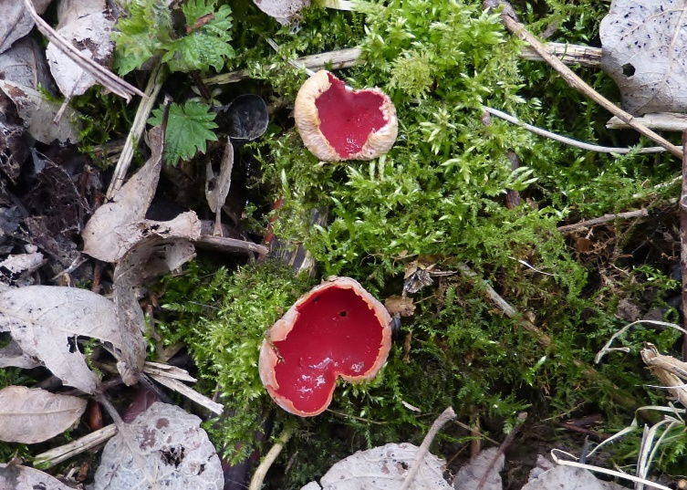
The rain calmed a little as we crossed back over the road to take the Riverside path starting just a short way up Lockwood Scar. The wood to the right, the side of the mill to the left and the darkness of the day had given Spa Wood an eerie feeling, the woodpigeons and crows mainly crouched up against the trunks of the old gnarled trees trying to keep themselves dry. Past this mill we start to walk by the river which is rushing down to town as if it hasn’t a moment to spare, it looks great and sounds wonderful, but there are no stones for the Dipper to sit on and unfortunately we didn’t see one, just the odd Blue Tit and Great tit flying amongst the branches of the trees overhanging the river and the Robin looking as though it was waiting for someone to feed it. We could see someone taking a photograph, so Stephen and I went to look what they had found, some Scarlet Elf Cups had grown on the moss-covered path, small but brilliant red coloured and interesting for most people on the walk.
Now up through Spa Wood to Wood Terrace, and the rain almost stopped, the views at the top of this road are far reaching and you can pick out various places in Lockwood and surrounding areas, also if
(14)
any birds were lurking in the woods we could see them as we were now looking down onto them. I’m sure the birds were there, but they would be sheltering from the wind and we didn’t see them.
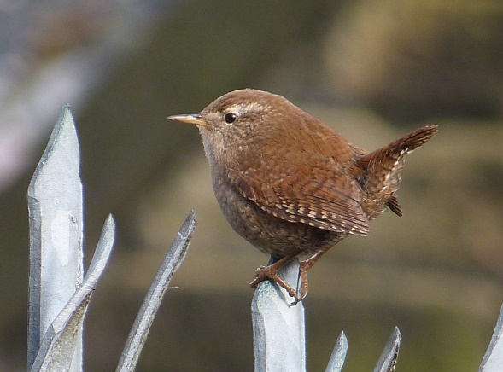
We crossed over the road now half way up Lockwood Scar, and located the footpath which goes, from Newsome to Lockwood, past the College Farm where students learn about animal husbandry. We hear and see a wren here and house sparrows chattering in the hedge which surrounds the Lockwood pub at the bottom of the field which is called “Salford Green”, not “Lockwood Green” as I told everyone.
“The Scar Cafe “is still open and after handing out some reports of the birds that can be found on the walk, some of us enjoyed a coffee and snack.
Although not many birds seen today, only 13 different species, the group seemed quite happy and said they would love to come back again maybe in the spring.

REPORT ON DEAN WOOD 1967
By M L. Denton & S. N. Anscombe (Members 1967)

Dean Wood is situated in a steep sided valley between Netherton and Crosland Hill, the wood consists of eight species of trees and has an undergrowth of bluebells and ferns, A small trout stream runs in the bottom of the valley and a small tip attracts many birds. The wood is visited regularly by four members and last year it was visited 83 times by two of the four and a total of 67 species were seen.

LIST OF SPECIES. * Denotes breeding species and numbers concerned.
- Mallard a male was seen to fly W on 26th June.
- Kestrel singles present throughout the year
- Lapwing large numbers were seen moving throughout the year with a maximum of C.200 flying W. on 15th August.
- Golden plover occasionally seen outside the wood with a maximum of 68 on 14th February and 130 on 15th August.
- Snipe two records for the year with thee flying E on 19th August and 7 flying W on 24th October
- Woodcock singles seen on 4th March and 9th April.
- Curlew one flew E on 14th April
- Great Black-Backed Gull seen occasionally flying towards Black Moorfoot in the evening.
- Lesser Black-Backed Gull seen on most visits flying towards Black Moorfoot with a maximum of 162 on 17th August.
- Black-Headed seen on every evening visit, flying towards Black Moorfoot with treble figures on five occasions and 429 on 12th October.
- Stock Dove seen occasionally with 4 throughout September
- Wood Pigeon* 1 pair – present throughout the year with 32 on 11th November
(15)

- Cuckoo one heard on 2nd June.
- Tawny Owl * 1 pair – no sight records but a destroyed nest found in May
- Swift first on 3rd May with up to 50 until the last on 21st August.
- Green Woodpecker *1 pair – present throughout the year but now more than two birds were seen at any one time
- Great Spotted Woodpecker only seen on two occasions, but it may have bred.
- Skylark * 2 pairs – present in the fields withy C.50 on 20th October.
- House Martin only seen in the autumn in very small numbers.
- Swallow * 4 pairs – first on 21st April with up to 30 until the last on 22nd August
- Carrion Crow seen throughout the year in singles or small parties.
- Rook most of the birds were seen to come from the Berry Brow rookery and the wood is probably a local feeding area for them.
- Jackdaw * 1 pair – seen throughout the year.
- Magpie * 2 pairs – present throughout the year but in no large numbers.
- Jay present throughout the year in good numbers.
- Great Tit * 1 pair – present throughout the year in good numbers.
- Blue Tit * 1 pair – present throughout the year in good numbers.
- Coal Tit seen occasionally.
- Long-Tailed Tit only two records of two on 12th April and 3 on 8th November.
- Tree Creeper – seen in most months of the year.
- Wren * 5 pairs – present in very good numbers
- Dipper seen on the stream in the first four months of the year and again in early December, with one being ringed on 18th February.
- Mistle Thrush * 1 pair – seen throughout the year and flocking in August and September with 35 on 30th August.
- Song Thrush * 2 pairs – present but only in small numbers.
- Field fare last seen on 26th April with 41 birds and first on 10th October with up to 350 in March and April.
- Redwing last on 23rd March and first on 23rd October with 35 birds seen
- Blackbird * 3 pairs – present but not in large numbers.
- Wheatear seen on the tip from 5th July to 17th August with 5 birds on July 11th.
- Redstart * 2 pairs – first on 10th May and seen or heard throughout the season with the last on 18th September. Four seen regularly.
- Robin * 4 pairs – present in good numbers.
- Blackcap one on 13th June and 21st were the only records.
- Garden Warbler only definite record of one on 3rd June.
- Whitethroat * 1 pair – present in June with the last on 17th August.
- Willow Warbler * 2 pairs - first were six birds on 26th April and last on September 18th, with good numbers throughout the summer.
- Wood Warbler first seen on 20th May and heard singing until 6th July. Breeding not proved.
- Goldcrest seen only in the winter months.
- Spotted Flycatcher * 2 pairs – first on 20th May and present in good number up to 15th August.
- Dunnock * 3 pairs – present regularly.
- Meadow Pipit seen on tip in the last three months of the year in small numbers.
- Tree Pipit one heard singing on 5th June.
- Pied Wagtail seen throughout the year may have bred.
- Grey Wagtail seen twice in January, once in March, twice in Oct. and twice in Dec.
(16)
. Yellow Wagtail one on 8th August and one flew E on 7th September.
- Starling * 3 pairs – seen throughout the year. Also seen flying over the wood in the
direction of Huddersfield with a maximum of 366 on 12th September.
- Greenfinch * 1 pair – no large numbers but seen regularly.
- Goldfinch three on 4th November and 4 on 11th November.
- Linnet * 2 pairs – seen occasionally in the autumn but only in small numbers.
- Twite two seen near the wood on 23rd May.
- Redpoll seen in good numbers with six on 10th October.
- Bullfinch *1 pair – present in good numbers.
- Brambling seen in small numbers in the first two months.
- Chaffinch not a common species but with 10 on 23rd October.
- Yellow Hammer four seen throughout the year except in August and September.
- Corn Bunting three were roosting in the wood on 14th April and other records of one on 23rd October and two on 11th.
- House Sparrow * 6 pairs – not a common species. One flock with C.50.
- Tree Sparrow * 2 pairs – common throughout the year with 75 on 7th September.

Hope you found this of interest. Perhaps someone would like to take up watching this wood and see if it is the same now. ED.

NOTICE OF ANNUAL GENERAL MEETING

The 56th Annual General Meeting is to be held in Huddersfield Town Hall
at 7.30pm on Tuesday 1st November 2021.

A full Agenda will be published on the Club Website
before the meeting.

SUBSCRIPTIONS AND CONTACT DETAILS

HI ALL,

IF YOU HAVE ANY RECENT CHANGES TO YOUR CONTACT DETAILS E.G. ADDRESS, PHONE NUMBER OR EMAIL WILL YOU LET ME KNOW. I NOTICE A LOT OF MEMBERS HAVE LANDLINE PHONE NUMBERS AND NOT MOBILE WHICH IS FINE, BUT IF YOU JUST HAVE A MOBILE NOW WILL YOU LET ME KNOW.

IF YOU ARE NOT COMING TO ONE OF OUR MEETINGS STARTING IN SEPTEMBER, I AM ASKING IF YOU WILL KINDLY SEND IN YOUR SUBSCRIPTIONS:

Single £19 couple £30

If possible by bank transfer to our HSBC account:
Sort code 40-25-10
Account number 40462195
Huddersfield Bird Watchers Club

Or by cheque to:-

Hazel Sill, (membership secretary), Wards End Farm, Marsden, HD7 6NJ
hazelsill@hotmail.com 07854739646

(18)

Birds in Huddersfield
Our annual report for 2021 is currently being written by David Sill, John Parkinson, Dave Pogson and Alan Wiggins based upon the records gathered by Nick Mallinson. Stuart Brocklehurst has produced another beautiful piece of art for the cover – this time a Little Ringed Plover.
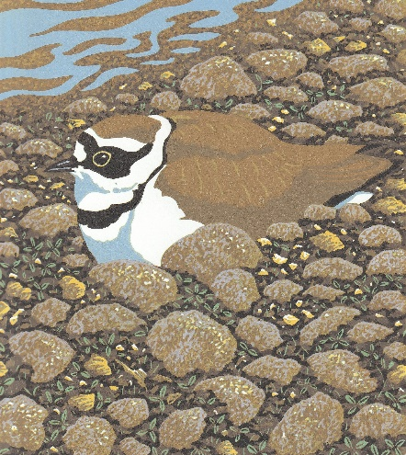
.
Of course, this will be available in the Autumn as usual.
Our Annual Report contains all the records sent in from all our local bird watchers and beyond and our Club is very proud to produce this culmination of our year’s work.
Spoonbill at Horbury by Nick Mallinson
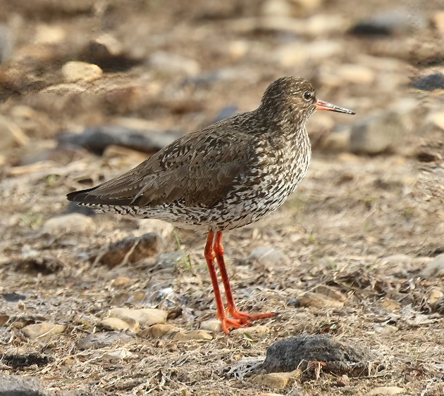
Redshank adult (juvenile overpage) Mick Mail

(19)

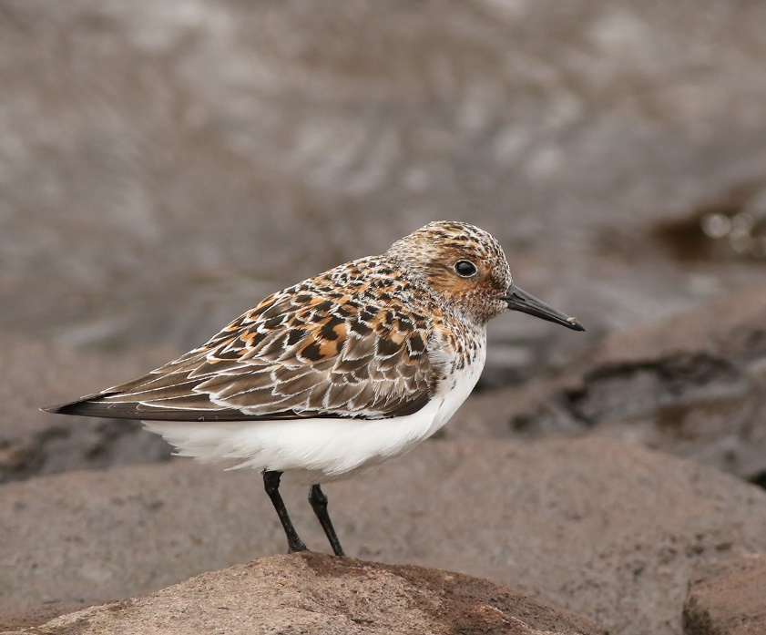Sanderling, Deerhill Reservoir. Dave Pennington

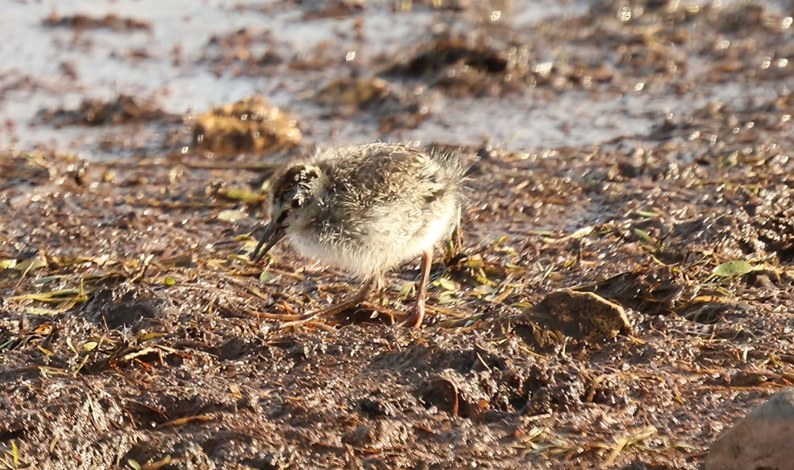
Redshank chick (adult inside cover) Mick Mail

