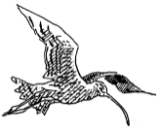
HUDDERSFIELD BIRD WATCHERS’ CLUB

NEWSLETTER
2020
Registered Charity No. 1098296
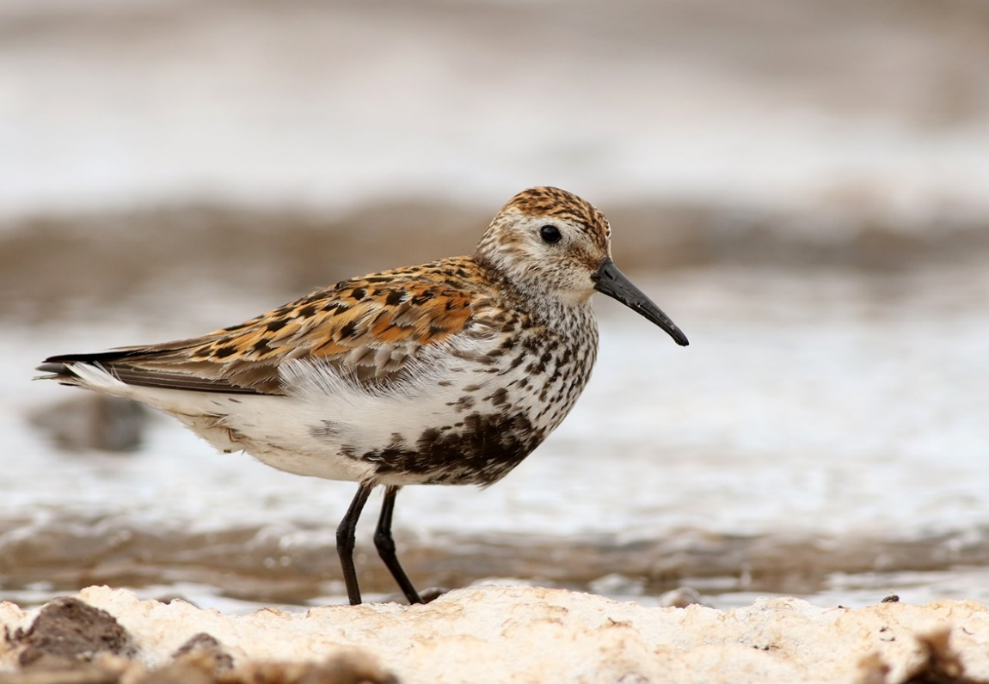

NEWSLETTER 2020
Contents  PRESIDENT’S JOTTINGS  EFFECTS OF CORONA-19 ON CLUB ACTIVITIES  LOCKDOWN BIRDING  IT WAS SO NEARLY HERE!  COPING WITH LOCKDOWN IN LOCKWOOD  KAZAKSTAN  MELTHAM THEN AND NOW  TWITE AROUND WARDS END  FARM  MOSLEY 2  2019 REPORT – LIFE DOESN’T STOP HERE  INDOOR MEETINGS 2020-21  ANNUAL GENERAL MEETING  Front cover: Dunlin by Dave Pennington | 3  3  5  6  8  11  13  14  17  18  18  23
‘

PRESIDENT’S JOTTINGS

The Club, thanks to its dedicated officials and members, continued to prosper. One of the main aims of the Club has always been to promote the education of the public in wild birds and their habitats. The lecture programme is one of the best ways to achieve this and, thanks to Alf King’s dedication to finding interesting and entertaining speakers, we got off to a flying start. The Annual Report had been printed ahead of schedule and was well received.

In 2018 we published, as an e-book, Seth Lister Mosley’s An Account of the Birds of the Huddersfield District. At the time we were unaware that some of the original printed volumes contained an illustration of Red-necked Grebe in place of that of Eared (Black-necked) Grebe. Thanks to the efforts of Steve Cook, however, we managed to obtain a copy of the picture, and this is now included in the e-book on the Club’s website.

The recent technique of recording the flight calls of birds as they pass over at night is revolutionising our understanding of nocturnal migration. We have all listened to the ‘seep’ calls of Redwings as they pass over during the night, but one of our more enthusiastic members, Dave Pennington, has grasped this new technology and some fascinating results have been accomplished. During the months of April/May of this year, for example, he recorded Common Scoter on two occasions, along with Teal, Wigeon, Water Rail, Whimbrel, Common Sandpiper on three occasions, and Moorhen and Coot were regularly recorded. In addition, an Olive-backed Pipit sound recorded as it flew over Harden Quarries in 2017 was a new species for the Club area.

With the exception for the AGM, this is the only time that I get to sing the praises of Club officials. The behind-the-scenes running of the Club tends to go unnoticed by members, simply because it is undertaken by a dedicated team who carry out their duties with little fuss. The team hasn’t changed since last year and consisted of Chris Abell (Secretary), Alf King (Indoor Meetings Organiser & Web Site Manager), Nick Mallinson (Recorder), Trevor Doherty (Treasurer), Hazel Sill (Membership Secretary & Newsletter Editor), Roger Mitchell (Publicity Officer), and committee members David Sill, David Butterfield, Stephen Cook, and John Walker.

All was going remarkably well, and we were all looking forward to the return of our summer visitors, then along came Covid-19 and put paid to all sanity. As we ease out of lockdown, Chris Abell, Alf King and Trevor Doherty, speculate on how this terrible disease will affect the Club in the long-term (see next article).

Mike Denton

Effects of Covid-19 on Club activities

The Coronavirus has had terrible effects on all our lives, losing loved ones, being in lockdown for months, not seeing family etc. As a Club we had to cancel Patch Outings and the remaining Indoor meetings for the 2019/2020 season.
3

The current situation has meant HBWC cannot fully meet our objectives which are :-

To study and record the wild birds of the area and to publish an annual report.
To promote education of the public in wild birds and their habitats.
To support research into and conservation of wild birds and their habitats.

However, we continue to strive to meet them as best we can, and the support of members is vital to ensure the long-term viability of the Club. As an example, the preparation of the 2019 Annual Report is well underway and we aim to publish a 2020 Annual Report although the data is likely to be limited because of the Covid-19 restrictions in place during the breeding season.

As I write the future is unclear and in the light of this uncertainty, the Committee has decided to waive subscriptions for existing members for the 2020/21 season. Because we are a charity the Trustees have consulted Charity Commission guidelines, and this is a step we are allowed to take. The Club has sufficient funds to allow this for 1 year without jeopardising our financial stability.

Elsewhere in this Newsletter you will read the exciting Indoor meetings Program that Alf has prepared for the next season starting on 8th September. However, currently Kirklees are not allowing meetings and the situation is under constant review as they await further Government guidance. We are in regular contact with them and will post any news on the Website and Forum as the position becomes clearer. Members are encouraged to look at them regularly for the latest information which will include any precautions required for attending meetings. We will also post information on our Twitter feed.

The Committee are in regular contact with each other to ensure that decisions are taken in the best interests of the Club and members. We would welcome any feedback from members on any issue related to future meetings and in particular:

Would you attend Indoor meetings if allowed from September?

What measures, if any, would you like to see to make you feel safer when attending meetings?

Any ideas you may have to ensure that the Club meets the needs of members as well as fulfilling its charitable objectives.

Please send you responses to me or any other Committee member by email, phone, text or letter. Hazel Sill will collate all your replies which will greatly help the Committee in making future decisions in these uncertain times.

Chris Abell Hazel Sill
01484681499, 07929863115, 07854739646
cdabell@gmail.com hazelsill@hotmail.com
23rd June 2020

4

Lockdown Birding

Whilst on holiday in Italy in February in an idle moment my mind turned to birdwatching plans for the Spring. As I had no Guiding or Norfolk commitments, I started thinking about my favourite sites in the Peak district and how to fit visiting them in with Club responsibilities, seeing the family and day to day tasks as well as maintaining the garden. I then read in the news about a strange virus emerging in China, but it seemed so far away as not to worry about it especially as past viruses like SARS, Ebola, Swine flu, Bird flu had not caused any disruption to daily life.

I had read of more cases in Northern Italy, but we were on holiday just outside that zone. However, a few days later a tent was erected at the hospital just around the corner with notices about Coronavirus and the setting up of a testing facility. That’s when reality struck. I realised how serious it was when our Government issued instructions that people entering UK from Italy had to go into self-isolation. My wife and I decided to cut short our holiday. On arriving home, we went straight into self-isolation for the mandatory 14 days. A day after we had completed our “sentence” the Government imposed the UK lockdown. Obviously, birding plans were now out of the window. The question remained how will I manage any birding?

Fortunately exercise once a day was allowed providing social distance was maintained. Cheesegate Nab is within walking distance and at least I could go and look for Ring Ouzel on migration. If I went early in the morning there was little chance of seeing anyone.

On my first walk to Cheesegate Nab (referred to from now on as CGN) I realised I had to do more than look for scarce migrants so I set myself the task of recording everything I saw in the hope of learning more about the wildlife in my neighbourhood. The area walked is roughly SE10T bounded by New Mill Dyke to the West and Cheesegate Nab to South and East, with our house the most Northerly point. I generally stuck to a route of 6.5 km with an ascent of 260m. Our house is at 204m above sea level with the highest elevation reached 367m, so my birding involved some strenuous physical effort. I occasionally varied my route to take in New Mill Dyke and Meal Hill.

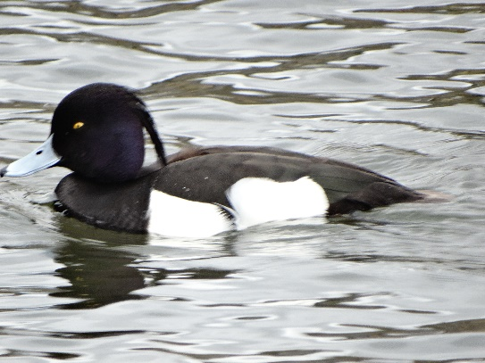
Between 23rd March and 31st May I recorded 67 species from 14 visits. Of these the majority were on my standard walk with New Mill Dyke contributing my only Grey Wagtail record and the ornamental lake at Meal Hill adding Little Grebe, Tufted Duck, (see picture)
Wigeon, Moorhen and Coot. Mallard and Canada Goose use the lake, but both were seen regularly on my walk.
CGN is well known in the Club as a good spot to see Ring Ouzels on migration and indeed I was fortunate to see them on 4 occasions between 1st April, (when a male was accompanying a flock of Fieldfare), and 27th. Other species using it as a migration stopover were Wheatear (seen on 4 occasions) and a pair of Oystercatchers on 7th May. Cuckoo came through between 5th and 7th May.
By watching the same spot regularly, I noted the arrivals of migrants, Chiffchaff (first 23rd March) Willow Warbler on 7th April, Blackcap on 14th April, Whitethroat on 27th April. A pair of Garden Warblers were seen on 29th May. While the number of singing Chiffchaff reached a peak of 14 on
5
27th April it declined to 4 by 12th May, Willow Warbler numbers increased to a maximum of 31 on 27th April and in late May there were around 20 singing males.
Whilst warblers were present in good numbers the same can’t be said for Hirundines. Swallows can be seen around the farm buildings, with possible breeding at 4 different sites, I have not seen any House Martins on my walk. The only record of Swift was 2 flying North on 11th May. The farm buildings hold breeding Tree and House Sparrows and the gardens around them are good spots for other breeding Passerines.
CGN is a favourite spot for Corvids using the updraft to fly westward with Jackdaw, Rook and Carrion Crow abundant. Magpies are common, and Jays have now spread up to the highest level. I saw Ravens on 3 occasions, with 3 on 27th April but the birds were scared off by a farmer.

The slopes of CGN hold Yellowhammer (up to 4 pairs), and Linnet. Lapwing (2) and Skylark (6) breed on the plateau with Curlew seen regularly displaying just over the eastern horizon.

Buzzards were seen regularly up to 27th April often around one particular tree, but then it went quiet after that. However vigorous calling was heard from that tree in early June suggesting a possible breeding site. One or 2 Kestrels have been seen regularly and Sparrowhawk on 3 occasions. Tawny Owl has been heard and a Little Owl showed well on 29th May and was seen again in early June.
Nuthatch is an interesting species with good numbers present in the valley on 23rd March but only moved up the hill on 7th April to 2 sites where vigorous calling was heard on 3 occasions. They went quiet after 27th April, but on 29th May activity was once again watched for some time at one of the sites where breeding is strongly suspected.

Breeding of Song Thrush has been confirmed at only 1 site on my regular walk, but I was surprised to hear 7 singing males on 17th May when I detoured along New Mill Dyke.

One of the delights of the early morning walks was seeing up to 3 Brown Hares regularly throughout the period and watching them boxing and exhibiting other breeding behaviour in early April. Other mammals include single sightings of Weasel and Roe Deer. Fortunately I came in little contact with Homo sapiens, seeing only a few dog walkers, horse riders and cyclists although on one occasion I had to take quick evasive action from motor cyclists.

Despite the radical change of plan and restricted birding I have thoroughly enjoyed my trips up CGN, even the strenuous climb. I have learned a lot about the local fauna and my understanding of bird migration. I hope to see the young of breeding species during the Summer and then look forward to what Autumn migration will bring.

Chris Abell
3rd June 2020

IT WAS SO NEARLY HERE!!!

You will no doubt have read about the White Storks that have hatched six chicks in Knepp, West Sussex, the first successful breeding in the UK since 1416 at St. Giles Cathedral, Edinburgh. This immediately reminded me of 2004 when a pair began nest building on an electricity pylon by the canal at Horbury. It was so low over the tow path that the birds were close overhead as one walked by. Brian Armitage’s article below and Stuart Brocklehurst’s cover for our 2004 report told the story:
6
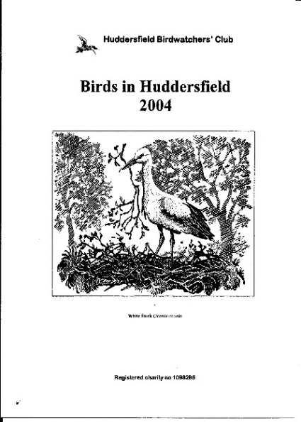
THE WHITE STORK STORY

When two White Storks (Ciconia ciconia) appeared at Bretton Park on 16th April it was assumed that they were wanderers from the Harewood colony, but this assumption was quickly dispelled when they were both found to be carrying foreign rings. They took up residence in the Sculpture Park and on the roof of the College buildings, where they displayed and carried sticks. During the afternoon they flew off to the east, briefly visiting Cannon Hall, but returned to the original site, displaying and bringing more nest material until c.10.30 hrs on 17th, when they flew off again.
Two White Storks, presumably the Bretton birds, were reported flying over Elland GPs to the northwest at lunchtime that day and a farmer then reported them on his land between Middlestown and Thornhill Edge in the valley of the Smithy Brook during the afternoon. They were relocated in a field off Beck Lane, Netherton (Wakefield) on 18th and then moved the short distance to Horbury Strands adjacent to the Calder and Hebble Navigation, where they displayed and again began nest building on a pylon carrying high tension cables in a pasture field, roosting overnight on the pylon.
This behaviour continued on 19th, when engineers from Yorkshire Electricity removed the beginnings of the rudimentary nest, in the interests of both the birds, which would have been electrocuted if they had touched two cables simultaneously, as well as of members of the public using the towpath very close by. The birds were not deterred however and immediately carried on to build a nest in the same place, only to have their newest efforts thwarted again on 20th.
In the meantime, RSPB officers consulted with the landowners, informing them of the enormous significance of what might have been about to happen, with a view to erecting a “safe” nesting pole in the field adjacent to the storks’ chosen pylon, but permission was refused on the grounds that “agricultural activities” would be compromised and substantial compensation would be required. Since the only agricultural activity was the grazing of a few head of cattle this excuse was indefensible but could not be countermanded. In view of the reputation of the landowners, who shall remain nameless, but are well known to the local community, their attitude was not surprising.
As a last resort, on 20th April a pole surmounted by a nesting platform was erected on the towpath itself but was obviously not to the birds’ liking and they did not add to the nest material that had been provided. They returned to Bretton Park, where they began nest building again in a dead tree near the heronry during the afternoon, but both were back at Horbury at 1800hrs.
At least one bird remained at Horbury on 21st April and the male was seen intermittently in the area to 29th, before appearing at Clitheroe, Lancashire on 30th.
Both birds carried rings that enabled their origins to be traced by the British Trust for Ornithology (BTO) ringing unit. The female had a French ring P6222 and had been found in poor condition in Calais in September and been taken into care before being ringed and released at Villeneuve d’Ascq near Lille in Northern France in February 2003. So, although it had been released from captivity, this individual could have had a wild origin.
7

The male, ringed with metal M5638 and dark blue Darvik 027, had been ringed as a full flying adult at an animal park in Belgium in April 2002. When originally caught it was also wearing a blue “chicken ring”, since lost, so was presumed to be an escaped individual. It was seen in Suffolk in April 2003 in the company of another, un-ringed White Stork.
Because of the distinctive combination of rings, both birds had been tracked via Hampshire, Bedfordshire, Cambridgeshire and West Midlands before arriving in West Yorkshire.
The only recorded breeding by this species in Britain took place on St. Giles Cathedral in Edinburgh in 1416. Who knows what might have happened had “our” birds chosen a safer site at Horbury where they could have remained undisturbed? An historic opportunity
Denied!

Brian Armitage (2005)

Mike Wainman
23/5/2020

COPING WITH LOCKDOWN IN LOCKWOOD

How to keep sane during lockdown: eat well, sleep well, keep busy, keep happy.
When you enjoy being out and about in the countryside, looking at the wildlife that our beautiful UK has to offer and finding peace and contentment in doing that, how can you stay in, stay at home. Boris has said “Stay at home, protect the NHS, save lives”, but he did also say “Wash your hands, only go on essential journeys, keep your social distance and exercise daily”. We have tried to do all of these.
Early in the morning each day just after breakfast we venture out into our local area, this is our hours exercise. Living only a mile away from Huddersfield town centre and in a built up area you would think it quite difficult to enjoy a walk, but……….we have the river Holme and an old Mill Dam which are not far from the bottom of our road, so this is where we go.
On a private road leading to the local Gym and Rugby Club, the river is on our left and the Dam is on our right. A pair of Great Tits are nesting in the only building before the Dam, and we often see Goldfinch and Collared Doves here. The Dam is surrounded by rough scrub and small trees and a Moorhen has built a nest under a dead tree which overhangs the water, occasionally we have seen a Kingfisher resting on this tree. Only Mallards seem to frequent this open water, but on the far bank one morning we spied a Sparrowhawk, it didn’t seem to see us and stayed all the time we were there. Another day a Mistle Thrush took our eye and as we watched it, we heard a raucous noise and looked across to a tree on the river’s edge, where a Jay was chasing a Song Thrush in and out of the branches, then three other Jays came to investigate, the poor Song Thrush was obviously very stressed but was giving the Jays a real telling off, perhaps it had a nest nearby.
The river continues at the other side of the road bridge and after looking at the Dam we stroll along ‘THE RIVERSIDE WAY’ entering at Wood End. It is a short walk following the river which is flanked with mills and businesses at one side and a tree covered hill at the other side. We have heard lots of small birds in the woods including Chiffchaff and Nuthatch, and a Great Spotted Woodpecker drumming in the trees high up on the bank, on the days that followed we spent time tracking these birds and yes we have seen them all now. There are two pairs of Grey Wagtails on the river one pair near the Dam and the other pair on a particularly stony patch of the river below a wrecked building which overhangs the water and is part of a mill complex. We have seen a Dipper in this area most days and today another Dipper came to join it, when it flew, we noticed it go underneath the overhanging building, we presume to its nesting site. We also surprised a pair of Goosander which flew off down the river when they noticed us watching. Today whilst we were
8
standing on the bridge in the centre of Lockwood, we were privileged to see not one but three Sparrowhawks soaring above us, being chased by a couple of crows.
These birds, which no one else seems to notice, have become our birds, and our accumulative total of species so far in Lockwood LOCK DOWN, is thirty-seven.
Our Home from Home
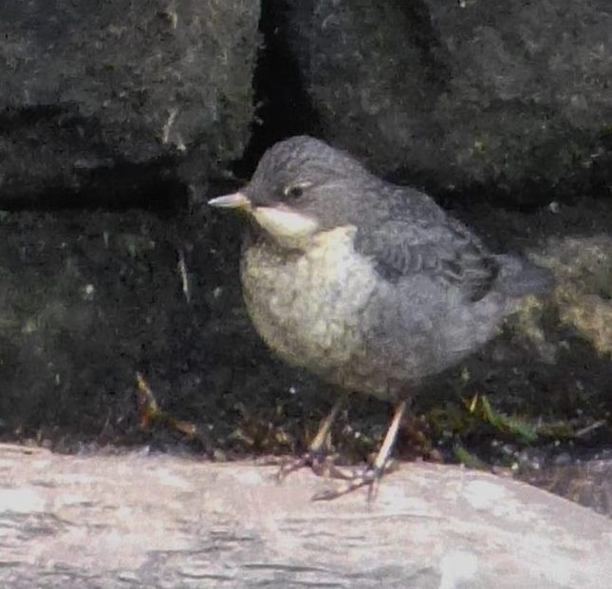
The days have turned into weeks and we are still going down to the river most days. The only surviving Moorhen chick is as big as mum and dad and quite capable of looking after itself. The Nuthatches have stopped singing, we have seen quite a few over these few weeks but now not one, if they are nesting they are keeping the sites very secret. We didn’t know that Lockwood had such an abundance of Blackcaps, but their song gives them away and has taken over from the Nuthatches, there must be at least eight pairs We couldn’t believe our eyes yesterday when we saw two Dippers on the river opposite the Dam and Stephen excitedly told me that one was a Juvenile Now we had seen a Dipper going into what we thought was a nest site. The place was under our feet in the richly moss clad wall which separates the tree lined road from the three-foot plant filled banking leading down to the river. A plank of wood laid on its side points to the exact spot where the Dipper always goes, but unlike the pair of Dippers further down the river, this particular one was never very active and we thought that perhaps the Grey Heron had eaten the eggs or chicks if there were any, as we had seen him watching and pointing his sharp beak towards the place where the nest was. It was such a lovely surprise to see the grey chick with its parent.
The two Dippers we had been watching down river were obviously feeding chicks, if we stood and watched for a while the parent would be busy swimming under the water, which flows fast through the stones which make this shallow river bed, always coming up with a beak full of insects and popping upwards to the nest site in the overhanging building and then back off again to collect some more tasty morsels, so it was no surprise to us to see their chick standing on a stone in the river waiting for its parent to come and feed it. We had by this time seen that the Grey Wagtails had a nest in the same broken down building, and on another special day saw three chicks on the stones waiting to be fed by their excited parents who were ‘talking to them all the time.

9
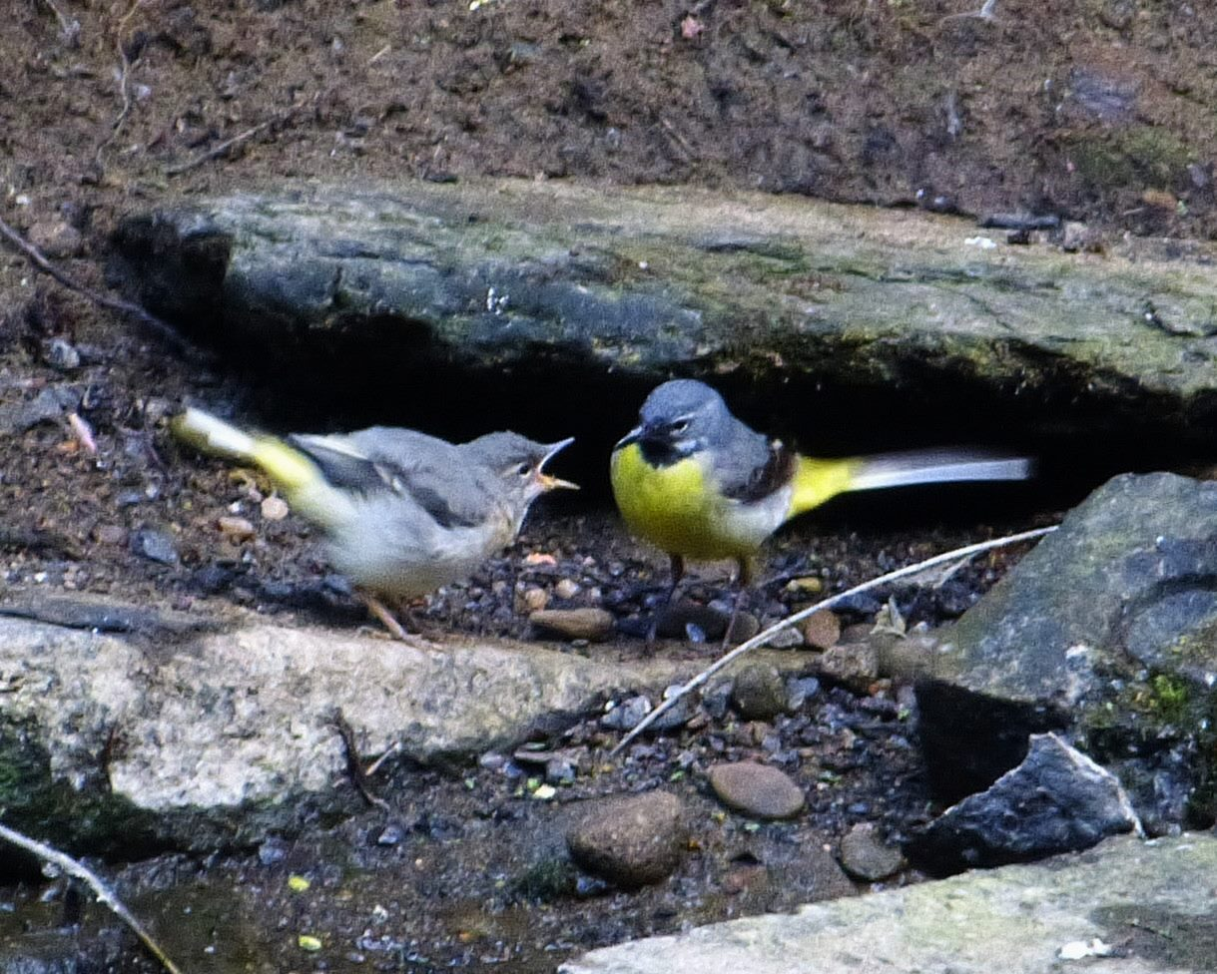
On a cloudy, rather cool day we had walked almost to the end of our trail, where there is a large open space which had once housed a company that collected and sorted rubbish from skips, somehow this rubbish had been set alight and had burned for several weeks, carefully watched by our fire service. Now it is derelict, but nature is taking over, the old knocked down walls, brick outhouses and burned wood timbers, are turning green with plants and bushes, it was here we saw our first glimpse of our Chiffchaff family. Lots of little brown chirping dots, fluttering in and out of the branches, whilst mum and dad called them, maybe telling them we were watching. Another day whilst looking to see if we could find the Chiffchaff family again, Stephen spied seven little balls of fluff all snuggled up together on a branch. One or two would flutter away then come back and hug their brothers and sisters again whilst mum and dad were making their high-pitched tweeting and kept coming to see their kids and presumably feeding them. We had seen Long-tailed tits around this area but hadn’t seen a nest or nest site and it was nice to know that they had managed to get seven of their little chicks to fledge. In a crack above an H, part of some street art someone has decorated the old broken walls with, is a Blue Tit’s nest. We see him balancing his tender little feet on what is left of the razor wire that decorates his particular stretch of wall, then glimpse him fluttering down, beak filled with food, straight into the crack that he calls home. Maybe it will be their chicks that are looking at the outside world in a few days. So, here’s to the next few exciting weeks of Lockwood Lockdown, can’t wait.

Stephen and Heather Chippendale

10
KAZAKHSTAN – MAY-JUNE 2018

Kazakhstan is the largest land locked country, covering over 1 million square miles. Bordered to the North and East by Russia and the Caspian Sea, to the East by China and to the South by 3 other States.
We left Manchester at 11.30 and arrived at our hotel in the new capital Astana at 03.45.
Astana has since been renamed Nur Sultan after the recently retired President. The capital is in the NW close to Russia and was built on the site of a steppe village. Tower blocks were being built whilst we were there. The city’s four lane highways were choked with traffic with many expensive new cars. Kazakhstan’s mineral wealth is reputed to have all the minerals of the periodic table plus oil.

We were a group of 10 plus the guide and the local guide and driver. Our local guide Victoria Koushar also advised oil companies on environmental issues. She informed us that there were about 20 birders in Kazakhstan and most of them were photographers. On our trips out Victoria and driver Alex provided us with picnic lunches with tables and chairs so we dined in style.

The countryside around Nur Sultan is steppe with a scattering of lakes and occasional clumps of trees. The city was clean, but the countryside was littered with plastic and empty vodka bottles. Originally nomads they were used to throwing things out and moving on, now the rubbish is plastic.

The day before we arrived it had been 30 degrees C., when we ventured out the first afternoon there was a strong wind and the temperature was 5 degrees C., and sleeting. We went to Sarykol Lake and saw Black and White-winged Terns, a Caspian Tern, White-winged Lark, Black-winged Pratincole, Garganey, Temminks Stint, Curlew and Terek Sandpipers. On the return journey we had good views of two Demoiselle Cranes.

On the way to Koorgalzhyn Nature Reserve, Red-footed Falcons, Oriental Turtle Doves, Black Larks and Sociable Plovers were spotted. At the reserve there were Booted and Blyth’s Reed Warblers. We had lunch by a colony of about 100 Black-winged Pratincoles. Moving on we stopped at a colony of about 300 pairs of Pallas’s Gulls with 50 Slender-billed Gulls, Common and Steppe Gulls. A surprise was around 1000 Red-necked Phalaropes by the water’s edge and thousands more passing over. At this site there were none the previous year at the same time. There were also about 150 Little Stints and Common Ringed and Kentish Plovers.

New birds the next day in a small river valley were: Common Rosefinch, Bluethroat, Pine Bunting and Eurasian Penduline Tit. On a second visit to this site we had, Paddyfield Warbler, Siberian Stonechat and Siberian Chiffchaff. At a small orchard we had our lunch and found Greenish Warbler, Tree Pipit and Spotted Flycatcher.

After a short tour of Nur Sultan, we took a 90-minute flight to the old capital of Almaty in the SW and close to China.

The next day we drove for 3.5 hours to artesian wells for Black-bellied Sand Grouse, Greater and Lesser Short-toed Lark, Calandra Lark, Bimaculated Lark and Masked Wagtail. We displaced some

11
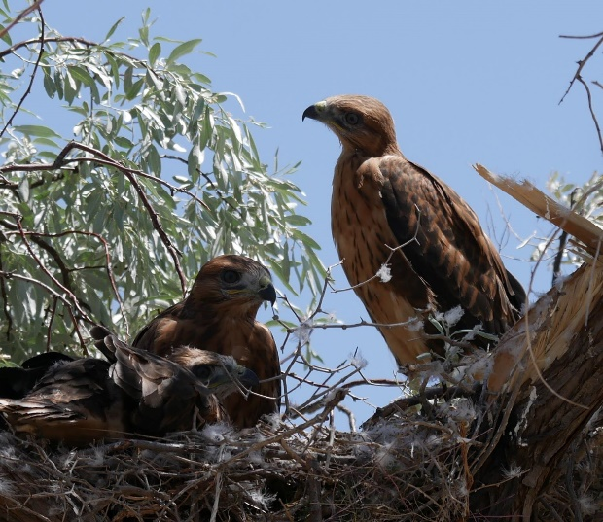
horses from under olive trees to have lunch. Above us Hume’s Warblers were calling. Close by were Red-headed Buntings, Tawney Pipit, Lesser Grey Shrike, Turkestan Shrike and nesting

Long-legged Buzzards with 3 well grown chicks. Exploring semi-desert, we found Greater Sand Plover. A short drive the next day, past many European Rollers and 200 Rose-coloured Starling in a tree, to Sumbuluk Lakes where there was nesting White-tailed Eagle, Dalmatian and White Pelicans, Ferruginous Duck and Black-crowned Night Heron.

En route to Kopec Pass we found White-crowned Penduline Tit, White- winged Woodpecker, Pale and Collared Sand Martins. At the pass were Rufous-tailed and Blue Rock Thrush, White-capped
Bunting, Rock Bunting, Chukar, Golden Eagle and Pied Wheatear. Descending to semi-desert at a very small artesian well were Grey-necked Bunting, Mongolian and Trumpeter Finch and Rock Sparrow. Close by were Desert Wheatear and Asian Desert Warbler. In the same area we saw a flying McQueen’s Bustard.

In the Kegan Pass area were Meadow Buntings, Lesser Kestrels, Black and Griffon Vultures. Lower down was Isabelline Wheatears, and near our hostelry Grey-headed Goldfinches, Barred Warbler and Long-tailed Shrike.

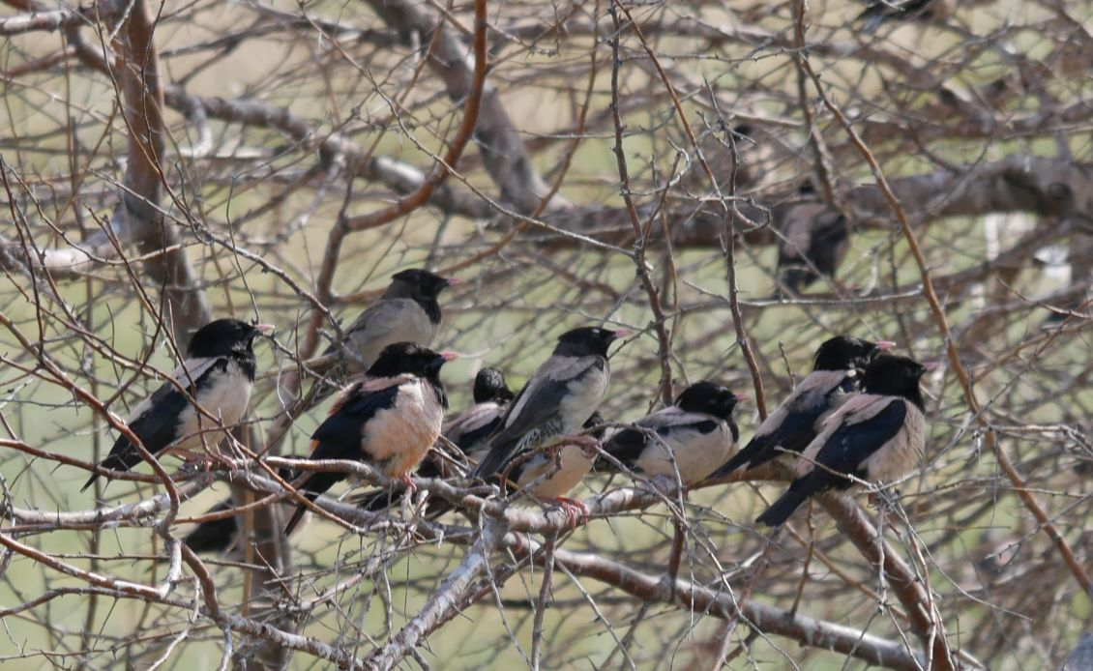

12

Our final two days were spent in the Tien Shen Mountains. Heading out we stopped for Brown Dipper, Blue-whistling Thrush, Black-throated Accentor and Three-toed Woodpecker. We were halted by a landslip and descended to the Big Almaty Lake which is at 8,238 feet. There were Eversmann’s and Blue-capped Redstart and Red-mantled Rosefinch. On the gravel plains where a river entered the lake were two pairs of Ibisbill with 5 chicks between them. Returning to our vehicle we disturbed 2 White-winged Grosbeaks.

Our last day out rewarded us with 2 Azure Tits. The landslip had been sufficiently cleared for us to squeeze past. Our destination was the Cosmo Station at 10,990 feet. The road was blocked by a barrier and our guide had to find an armed sentry who checked our passports before allowing us through. Here were Red-fronted Serin, Plain-mountain Finch, Brown and Altai Accentor, Guldenstadst’s Redstart, Red and Yellow-billed Chough, and some glimpsed a snowcock on the rocky slopes. Surprises for me, at this height, were, a Water Pipit and a Swallow passing over.

Descending from the thin air we lunched in a valley amongst wildflowers. Then we walked further down the valley where there was Severtzov’s Tit Warbler, Himalayan Rubythroat, and Sulphur-breasted Warbler. Our guide told us the latter had been virtually wiped out in this valley by bird traders.

After a fascinating tour of contrasts with over 220 species recorded we flew from Almaty back to Manchester back to Manchester via Istanbul.

Stephen Cook

MELTHAM BIRDS THEN AND NOW

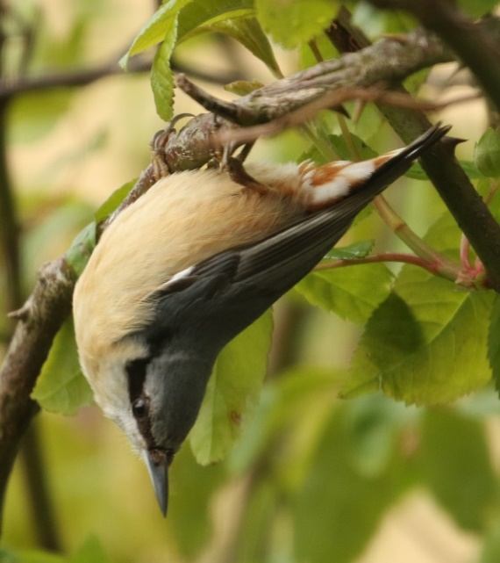
Watching my (few) local breeding Lapwings in Meltham in early May, valiantly dive-bombing the marauding Carrion Crows, got me thinking. The numbers of these two species used to be the other way round. In the mid-70’s when I first moved to this area, Lapwings seemed to be in every field with very few Crows. Now, the Crow population is eye watering with gangs of surplus nonbreeding birds everywhere.
Coupled with the different farming practices, like the mowing of hay fields for silage and the over-stocking of sheep in some of these fields favoured by Lapwings for nesting. Also the number of Pheasants that are released for shooting in this area is madness, they are all over the place I’ve seen them being mobbed by Lapwings on several occasions during the breeding season.

13
What of other species? Walking through Windy Bank Wood early one morning in mid-May, I was listening to singing Blackbird, Blackcap, Willow Warbler and Chiffchaff. This was pleasant enough, but there was no sight or sound of the hoped-for Wood Warbler, Pied Flycatcher and Redstart, these longed-for species, in common with other places in our recording area are missing.
A plus point at this site is the now abundant population of the splendid Nuthatch (see photo).
I remember the days when an excursion to Bretton Park was required to have any chance of seeing one in our area. Also, Common Buzzard over Meltham Golf Course is now a common and most
welcome sight that would have been unheard of not long ago. Regarding the moorland edges round Meltham, long gone are Yellowhammers and Tree Pipits, both these species were regular breeders in Royd Edge Clough, the former species was also a regular breeder in the Brow Grains area probably up to the 90’s.Whinchat is still hanging on at Brow Grains with at least two males and a single female seen so far this spring at this site, but they are no longer encountered in Royd Edge. On a slightly more positive note, Whitethroat seems to be doing well, especially in Royd Edge, and I‘m hearing, if not actually seeing more Grasshopper Warblers with each passing spring round the scrubbier edges in my local area. Reed Buntings now breed in some of the driest bracken beds, this would have been unheard of in the 70’s.
Stonechat is another species that seems to be doing well, I know of four pairs, more or less in a straight line (looking on my OS map) between West Nab and Deer Hill, all have young out of the nest as I write, and with this fine dry weather all pairs should hopefully go on to produce more young.

Now the saddest (for me) and most obvious and dramatic change.

In the spring of 2003 I volunteered to put some supplementary feed down for Twite, as requested by the RSPB, at a site near Deer Hill Reservoir. The seed soon started to attract Twite and a few Linnets with up to 20 of the former, including a couple of colour ringed ones from an ongoing scheme. Over the next few years an average of about 30 Twite were counted by mid-April, max count 52 birds mid 90s
Before this I noted Twite were often to be seen feeding on the abundant sorrel that is still a common plant in this area, the seeds of this plant, are very important, it’s milky unripe seeds and fully ripe hard seeds are an important food for both Twite and Linnet and their young. Twite nestlings are fed exclusively on regurgitated seed apparently. This plant seems to be still abundant in this area, so we can only hope for the best.

From 2015 a decline in numbers of Twite here became obvious.

The Deer Hill feeding station became a top site for this species and attracted many birdwatchers and bird photographers.

This year despite a good supply of seed (now financed by the HBC) the site only attracted c25 Linnets (another species that seems to be declining in this area) but not a single Twite.

Long before the feeding site at Deer Hill was established there used to be an Autumn build-up of Twite in the Deer Hill area that fed on the abundant thistles here. I could count probably 100 birds here in the 80’s in September.
This Autumn build-up had all but ceased by the mid 90’s. The fact that now this same area attracts about the same numbers of Goldfinches feeding in the same fields, on the same food, and at the same time of year, points to the fact that it’s not a lack of food at this time of year that’s a problem.
It’s puzzling that I don’t remember seeing many Goldfinch here in 70’s.

14
Who knows what the future holds for our local birds? Has global warming played a part in fluctuating bird numbers? I remember twitching my first Little Egret in the early 80’s, when this species was still a national rarity, little did I know then, that one day I would see one at a mill pond just up the road from home.
Finishing on a cheery note. I’ve managed to see five species of owl this year in and around Meltham and all before mid-April.

Dave Pogson
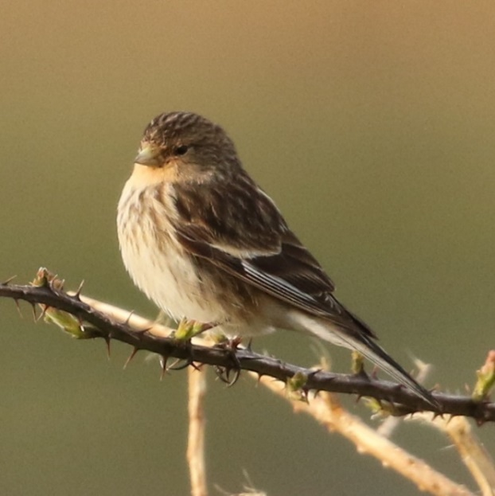

Twite around Wards End Farm.

We moved to our present house in October 2003 and at the time we had no idea how good, birdwise, it would turn out to be. We were doing a lot of travelling at the time and much of what we saw initially was spotted as we drove down the track (slowly by necessity) past the derelict Hopwood then down past White Hull Farm then Lower Green Owlers and beyond to the valley bottom. Apart from Stonechats, Whinchats and Wheatears in the fields and a very approachable juv. Merlin sat on a fence post by the trackside, flocks of Twite were much in evidence. They were seen regularly feeding, in particular on the waste ground around the old barn at White Hull Farm (now converted) and Hopwood which is, or was, immediately to the side of us. Whilst I wasn’t carrying out daily bird counts at the time all I saw was recorded.
It was after reading Dave Pogson’s interesting article on his Meltham observations that got me round to throwing a few figures together. Coincidentally the year he started putting seed down was when we moved here though it was some years later before we began to do the same. It must be born in mind that as Dave had a mile and a half trudge up to Deer Hill to put out seed in all sorts of weather we live ‘over the shop’ and most of the birds listed below were seen from the house or even through an ever open kitchen door.
Some of the highest counts were as follows
2003. 60+ 17th October
2004 60 28th August
2005 70 1st September 15

2009. 60 8th October
2013 68 13th October
2014 106 16th September, though included in the figures below this was by far the highest count. As they were sitting by the side of our house on our electric supply making so much noise that Hazel thought it was the cable ‘buzzing’, and that was from inside the house from where the photo was taken.

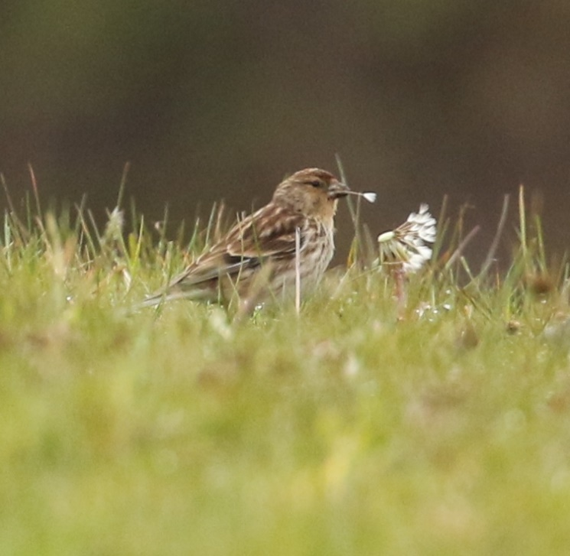
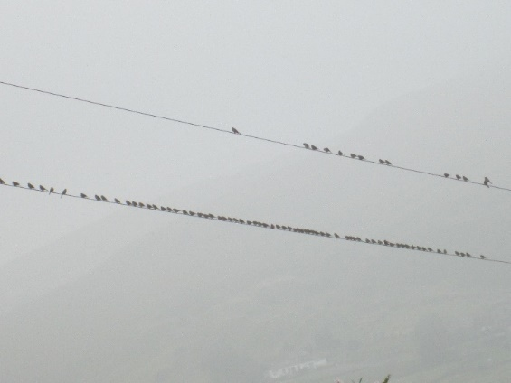
It must be born in mind that some of these higher counts are very often the result of smaller flocks joining, sometimes temporarily, but we can only count what we see. We must also bear in mind that all these birds are not necessarily ‘ours’ and that a proportion will be more Northern birds passing through.
106, 16th September, 2014
The same year as we began feeding I also started a daily vis- mig watch so the numbers in the table below include every Twite seen here including those. The figures for Spring 2018 look quite different and as you may recall (how could you forget?) The Beast from the East had an effect on many species. There was an obvious delay in returning birds and wintering birds may well have pushed even further South, even crossing the Channel to avoid the March freeze after which there followed a ‘mad dash’ back to normality.
Dandelion, a springtime favourite

16

Number of bird/days since daily watch began
 | March | April | May | June | July | Aug | Sept | Oct | Nov | Dec | Totals
2019 | 7 | 33 | 6 | 46 | 21 | 10 | 101 | 5 | 2 | 12 | 243
2018 |  | 4 | 155 | 8 | 23 | 184 | 116 | 49 |  |  | 539
2017 | 7 | 25 | 31 | 45 | 116 | 55 | 95 | 18 |  |  | 392
2016 | 6 | 19 | 3 | 23 | 13 | 40 | 82 | 16 |  |  | 202
2015 | 8 | 80 | 32 | 52 | 178 | 80 | 390 | 382 |  |  | 1202
2014 |  | 2 | 19 | 11 | 299 | 71 | 1511 | 535 | 27 |  | 2475

Dave Sill

MOSLEY 2

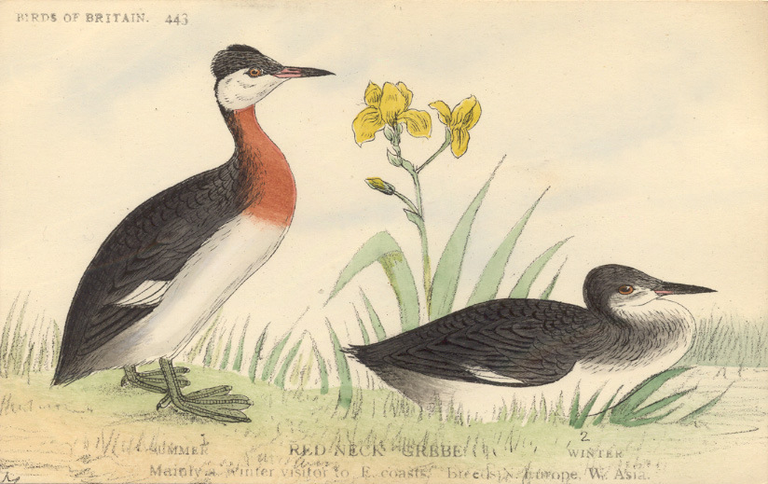
Since we re-published S.L. Mosley’s landmark 1915 work An Account of the Birds of the Huddersfield District as an e-book, further research by Steve Cook has unearthed another of Mosley’s colour plates of Red-necked Grebe. This was used by Mosley in some of his issues at the time in his sometimes-chaotic manner. We have therefore updated the e-book to a 2nd Edition, with kind permission from Kirklees Image Archive to use their copy, and this is now on our webs site to download. Mike Pinder has provided an updated Introduction and the extract below tells the story:

17

“The scans presented here are taken from a "complete" copy, containing 39 plates and 37 maps. We present it as it is, bar the omission of the blank pages, but otherwise retaining all the vagaries and ageing of the original. Our first edition published in August 2018 has a plate of Eared Grebe. As a result of research by Stephen Cook, it has emerged that some copies have a plate of Red-necked Grebe but not of Eared Grebe. Universities, Museums, and a private collector were contacted, and they had one or the other of these two plates but not both. We have been unable to locate a copy with both plates. For the sake of completeness, we have included both Eared and Red-necked Grebe in this updated edition (May 2020).”

Mike Pinder.

2019 REPORT – LIFE DOESN’T STOP

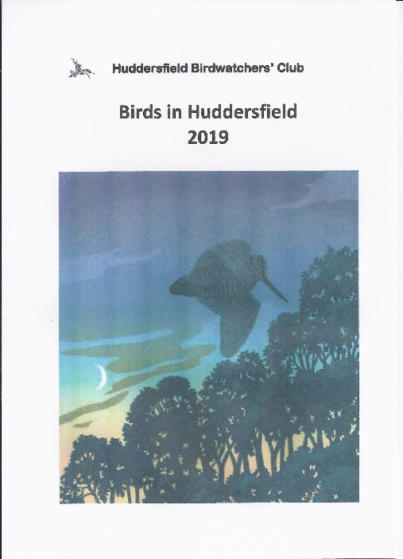
Despite or perhaps because of the lockdown, work on our 2019 report is progressing well. Recorder Nick Mallinson has computerised all the records, Mike Denton and David Sill have been busy writing, Stuart Brocklehurst has produced a cracking cover of roding Woodcock at dusk and I have been working to update the report format a little.

The Committee will decide in due course the best way to let everyone have their copy.

Mike Wainman

INDOOR MEETINGS 2020-21

Last season’s indoor meetings were well received, judged not simply on the basis of regular healthy attendances but also by the occasional compliment (most unusual) from members after the individual talks. As always Huddersfield Town Hall looked after us very well, all our speakers turned up on time and fully equipped, the talks were fascinating and entertaining in equal part and the audience responded positively throughout. So, we should be able to say that this was a highly successful season, but unfortunately Covid-19 curtailed matters abruptly. We should be able to make up this loss, however, as the speakers who were unable to visit last year have committed to

18

our next programme, which we are very hopeful of delivering in full.
To begin the season we were treated to some fabulous photos and stunning vistas by Ron Marshall, showing us the wonders of Torres del Paine in Southern Chile that he visited on a self-organised trip with friends; Mountain Lion was a specific and successful target for the camera. Closer to home Nick Martin spoke on a Photographer’s Wild Britain, showing us all what outstanding photos can be achieved by a skilled cameraman with lots of practice and patience. Laurence Rose delighted us with his imaginative and teasing view of Yorkshire Specialities (White-tailed Eagles, Corncrakes and others), the first of a run of three excellent presentations by Club members. David Sill once again revealed his in-depth knowledge, this time of things Sardinian, including the birds. This was so fascinating that he has agreed to return with Part Two this coming season. And Trevor Doherty presented us with the conundrum Photographer & Birder, Or Birder & Photographer? Was the question fully answered, we might ask (Trevor says that it was).
All the way from Filey once again Mark Pearson entertained with tales of that East Yorkshire Seabird Nirvana with some great photos and in-depth information of one of Britain’s birding hot spots. Before the year 2019 drew to a close we had the pleasure of once more welcoming that great favourite Paul Rogers to the Club to reveal even further secrets about Trinidad and Tobago.
The year 2020 started with a presentation by Alf King of a trip across Southern Africa, embracing mostly Namibia but a short time also in Botswana. The talk was accompanied by examples of photos that can be taken by an enthusiastic amateur; at least they captured the excitement of the trip. Our next speaker was John Reilly who gave a talk simply entitled “New Guinea” that belied the complex nature of the presentation, embracing not only a trip to the outer reaches of this island but also a thought-provoking insight into current thinking on speciation and avian evolution. The theme of presentations by Club members was continued with Reg Senior’s thoughtful talk on Two Islands and a Rock, taking in three disparate parts of the British Isles and accompanied by some spectacular photos. In March Ian Robinson revisited the town of his youth once again to talk to us about distant Bhutan – Land of The Thunder Dragon, which left this listener at least eager to visit that part of Asia when he can. As always with Ian’s talks there were spectacular bird photographs, wonderful landscapes and a short soundscape to round off with.
And then everything shuddered to a halt. The need to terminate our programme at that point was unquestionable and all meaningful activities of the Club was suspended (with the honourable exception of the writing of the next Annual Report) as we were confined to our homes for the duration. As I said earlier all the speakers who were unable to visit at the end of this programme have agreed to reschedule for 2020-21 so there should be no real loss overall.
The committee have regularly reviewed our options for the next season, details of which are dealt with elsewhere in the newsletter, and amongst other things it was agreed that we should organise our lecture programme as normal, whilst understanding that prevailing circumstances might change things as we go along. As yet, we are unsure about the details of access to rooms within the Town Hall, although our bookings are still being honoured. We do not know what the general advice will be for the public at large, with waves declining and increasing on a daily basis. We don’t know if all our speakers will be willing or able to travel. Last, but not least, we don’t know if our members will feel confident of attending group meetings of any sort. Understanding all that uncertainty, however, I have still managed to pull together an interesting and attractive programme that we earnestly hope to be able to deliver in the forthcoming season. Savour the details below in eager anticipation, then please do your best to attend.
Car Parking
As I hope that all Club members now know Alfred Street has been closed due to structural issues and looks unlikely to open again in the foreseeable future, if at all. This does mean that parking close to the Town Hall is quite limited, especially if there are other events at the same time. This applies particularly when we have meetings in Meeting Room 3 which usually means that The Old Court
19
Room is unavailable due to an event in the main hall. We would encourage all attendees at our meetings travelling by car to acquaint themselves as far as possible with all the other parking opportunities that Huddersfield has to offer. (Especially the more able bodied*), the Queensgate Market car park on Alfred Street
*Editor

OUR SPEAKERS THIS YEAR

Dawn Balmer
Dawn is the Head of Surveys at the BTO leading the team running most of its large-scale bird surveys, including the Wetland Bird Survey, Breeding Bird Survey, BirdTrack, Waterways Breeding Bird Survey and Heronries Census. In addition, Dawn also maintains and coordinates the Regional Network, BTO's network of volunteer Regional Representatives. She also has responsibility for the Regional Conference. Dawn has a long-term interest in migration and movements of birds and population dynamics and was the Atlas Coordinator for Bird Atlas 2007–11. Dawn is Secretary of the European Bird Census Council and Chair of the Rare Breeding Birds Panel. Amongst all this Dawn is a keen birdwatcher, ringer, general naturalist and enjoys photography.
This will be her first visit to the club, and she will give us an insight into The Mysteries of Migration.
https://www.bto.org/about-bto/our-staff/dawn-balmer

Mike Pilsworth
Mike is the Humber Conservation Officer with the RSPB with an oversight of all their reserves in and around the Humber. He lives in Swinefleet and is an avid birder and general naturalist. He will be talking to us about all the RSPB’s work in and around the Humber.

David Sill
David is one of the club’s more experienced birdwatchers and in particular loves the high grounds of Yorkshire with their ever-changing patterns of bird movements. As an indulgence of that love he lives with Hazel in a truly remote location above Marsden where he gains an exceptional perspective of birding in the club area. Previously he has provided a fascinating insight into Pennine birding and last year, as a true contrast, he spoke to us about the birdlife of the Island of Sardinia where he lived for many years. This will be his encore to that last talk.

20
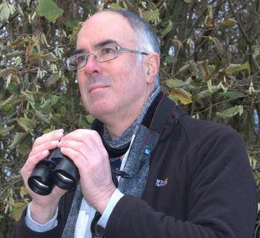
Laurence Rose has worked for the RSPB, from which he has recently retired from full-time work, for over 30 years in a variety of roles including Regional Director Northern England Region and, most recently, Strategic Project Manager based in Denby Dale, leading the “Back From the Brink” initiative. He is also a composer and writer, a Director of CoMA - Contemporary Music for All, a former Director of the Huddersfield Contemporary Music Festival and a business adviser to arts and conservation organisations. He is also a prolific writer and has had a number of books published, which include The Long Spring, a fascinating tale following the journeys of White Storks in Europe, and the recently released Framing Nature, which will be the topic of his talk.

David Tolliday
David is making a welcome return to the club visiting for the fourth time from his base in Cheshire. He is a wildlife photographer having been interested in wildlife for as long as he can remember with one of his first wildlife memories being of a flock of lapwings in a field at Cuckmere in Sussex when he was about ten years old. He was transfixed by these beautiful birds and they continue to remain one of his favourite species. His presentation features Holiday Wildlife in Florida and Spain.
http://www.davidtolliday.co.uk/

David Brierley
David is another club stalwart and a keen traveller and birder. One of his ambitions was to visit Antarctica which he fulfilled, whilst also taking in some of the South Atlantic islands. His tales and photographs of this journey will entertain us when he speaks on Following in Shackleton’s Footsteps.

Ron Marshall
Ron has been interested in wildlife since being a small boy but has been a serious Barnsley birdwatcher for the past 35 years. On retirement he developed an interest in photography which also coincided with greater opportunities to travel. This has led to him visiting five continents, always accompanied by his camera to record the sights of wildlife whenever the chance arises. In Europe, these opportunities have spread from South to North taking in Catalonia and Finland, amongst other countries. This will be the topic that he addresses.

Alf King
Alf is another of our club members making another presentation this year having previously described overseas trips that he has been fortunate in being able to make. This time, in 2019, he was lucky enough to be able to join up with a group of keen birders in Brazil and that will be the subject of his talk.
Steve Davies
Steve is the Chairman of the Peak District Raptor Monitoring Group who undertake a wealth of monitoring throughout the whole of the Peak District, a monumental task for a small group of highly dedicated individuals. This involves a whole range of tasks, mostly voluntary, embracing co-ordination and consultation with all interested parties and stakeholder in the district as well as the authorised monitoring, protection and ringing of raptors. Steve will be giving us a detailed presentation on the complex issues of Raptor Protection in The South Pennines
21

Paul Rogers
Paul is a most popular presenter to the club having delighted us on many occasions before with a diversity of topics. He has had a life-long interest in natural history, which is underlined by his qualifications in Ecology and Animal Behaviour gained at London University and he was a principal leader for Ornitholidays, having led over 210 tours. For some time now he has had the pleasure and privilege of living at Shorelands on Anglesey, the former home of wildlife artist Charles Tunnicliffe. He is widely travelled in Europe, North America and Africa and lectures on ornithology, ecology and all aspects of natural history. His subject for us this time around will be about that fascinating group of birds The Wonderful World of Waders.

Graham Sorrie
Graham hails from Morpeth and, as well as being a dedicated birder, has a long and abiding passion for Swifts, those brief but fascinating visitors to our skies. Graham’s interest is so great that he devotes much of his time to their conservation. He will talk to us about the ups and downs of Swift conservation in the North East as well as describing how birding communities throughout the country can help in this task in “Keeping Morpeth’s Skies Alive”. This would have been presented to the club last season but was postponed due to the Covid-19 problems and should be well worth the wait.

John Gardner
A professional commercial, portrait and beauty photographer based in Wakefield but covering the whole of Yorkshire and beyond., John is also a well-known wildlife specialist and wildlife photographer both in Yorkshire and further afield. He is an active member of the Wakefield Naturalist’s Society, of which he has been the President for a number of years and is a well-known speaker on many natural history topics. John will be speaking to us about Iberian Birds.
https://www.johngardnerphotography.com/category/bird-photography/

Gary Prescott
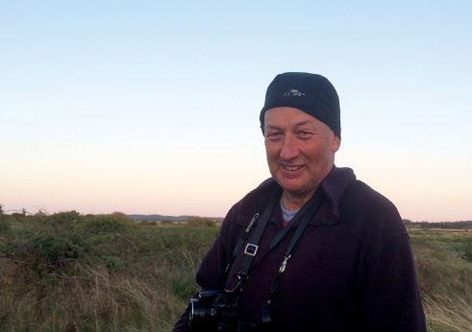
Gary goes by the name of “The Biking Birder” and refers to himself as “A UK Green birder, birdwatcher, twitcher and environmentalist”. He is a retired special needs teacher who now devotes himself to a wealth of environmental and birding projects, often through the medium of long-distant bike rides, of which he is also passionate. As those who have attended previous presentation by Gary will confirm he is also wildly entertaining.
In his next talk to the club “RSPB Reserves and Their Birds” Gary will describe an epic journey that he made visiting every one of the RSPB reserves in the country. Once again, this is a talk that has been rescheduled from last year’s programme.
http://bikingbirder2016.blogspot.com/

Mike Denton
Our own President Mike Denton should need no introduction; to say that he is a bedrock of the club would be an understatement. Once again Mike will be rounding off the presentation year with a review of the key sightings from 2020 coupled with photographs of birds in the club area taken by members and other local birders, in “2020 – A Huddersfield Birding Year”.
By Alf KING 22

NOTICE OF ANNUAL GENERAL MEETING

The 54th Annual General Meeting is to be held in Huddersfield Town Hall at 7.30pm on Tuesday 24th November 2020.

A full agenda will be published on the Club Website before the meeting.

The following posts are due for election to serve for 2 years: -

- Secretary

- Conservation

- Recorder

- 3 Committee Members

Nominations for these posts should be sent to the Secretary, in writing or by email, 14 days before the meeting.
(i.e. to be received no later than 10th November)

Please note that in the current situation regarding Covid-19 it is unclear whether the meeting can be held as planned. Please contact the Secretary for up to date information.

C D Abell 5/6/20

23

SOME OF THIS YEAR’S CROP
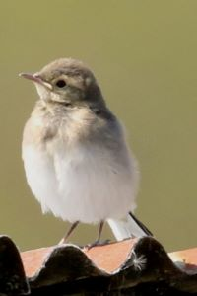
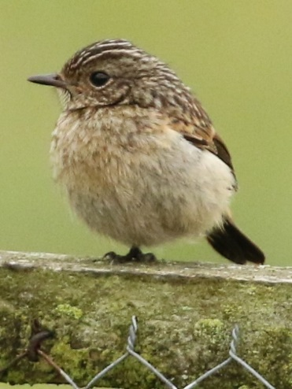
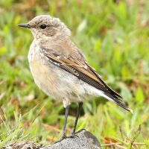
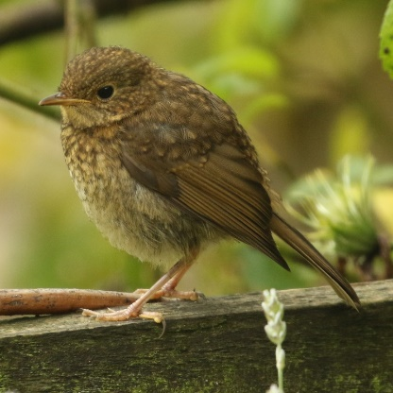
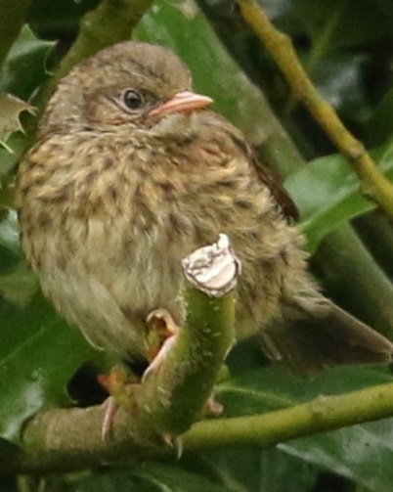
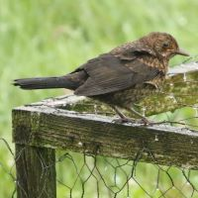
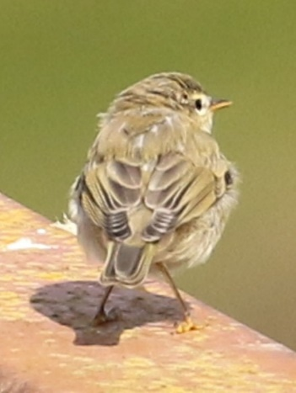
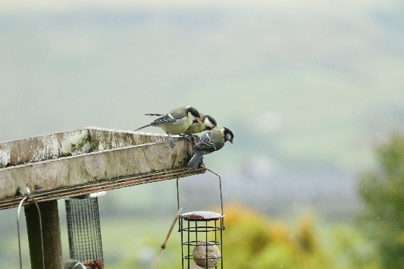
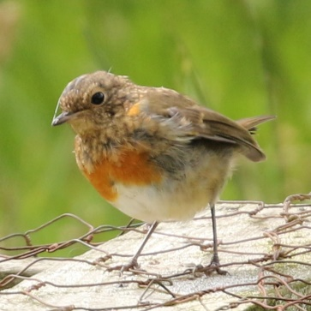
Top: Robin

Middle: Blackbird

Bottom: Robin

Top: Great Tits

Middle: Dunnock
Top: Willow Warbler
Bottom: Stonechat Middle: Wheatear
Bottom: Pied Wagtail

